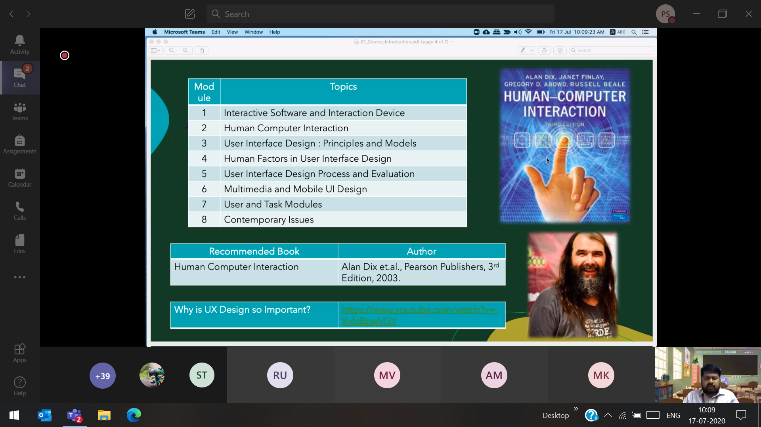

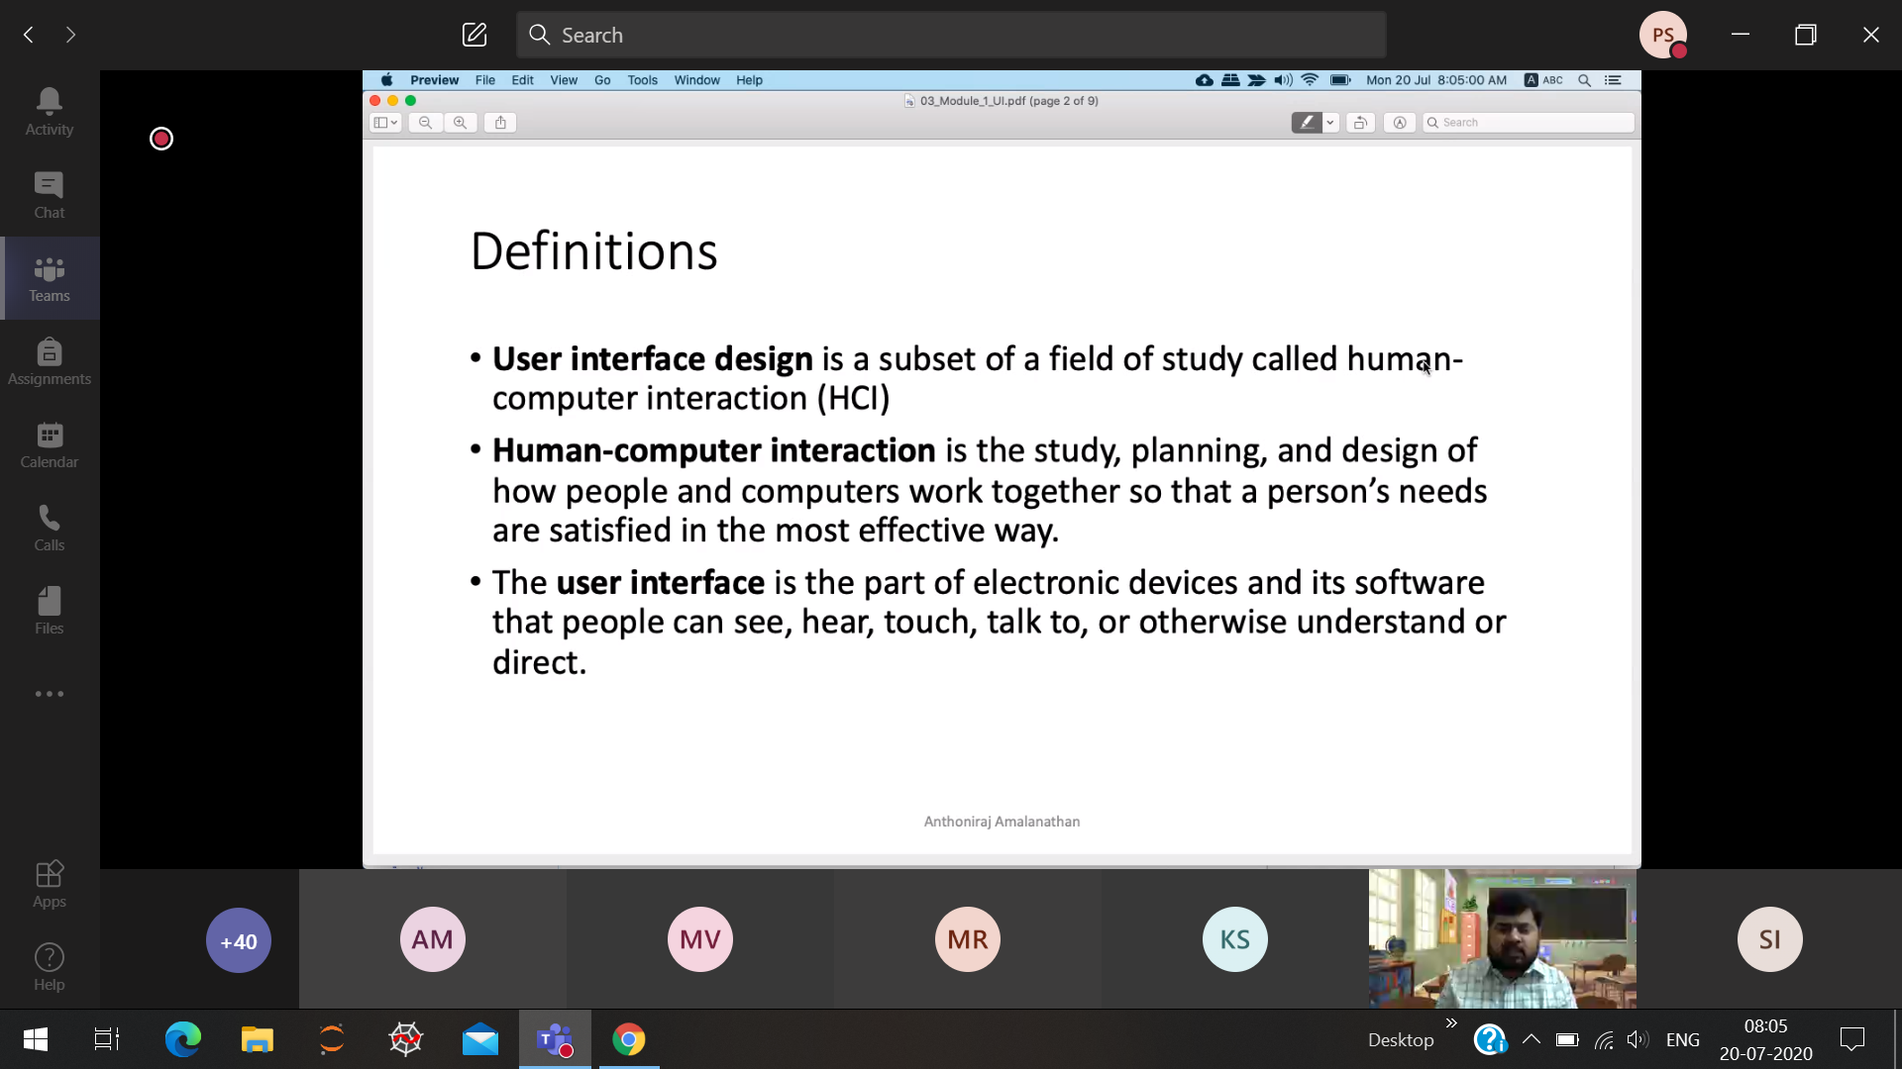

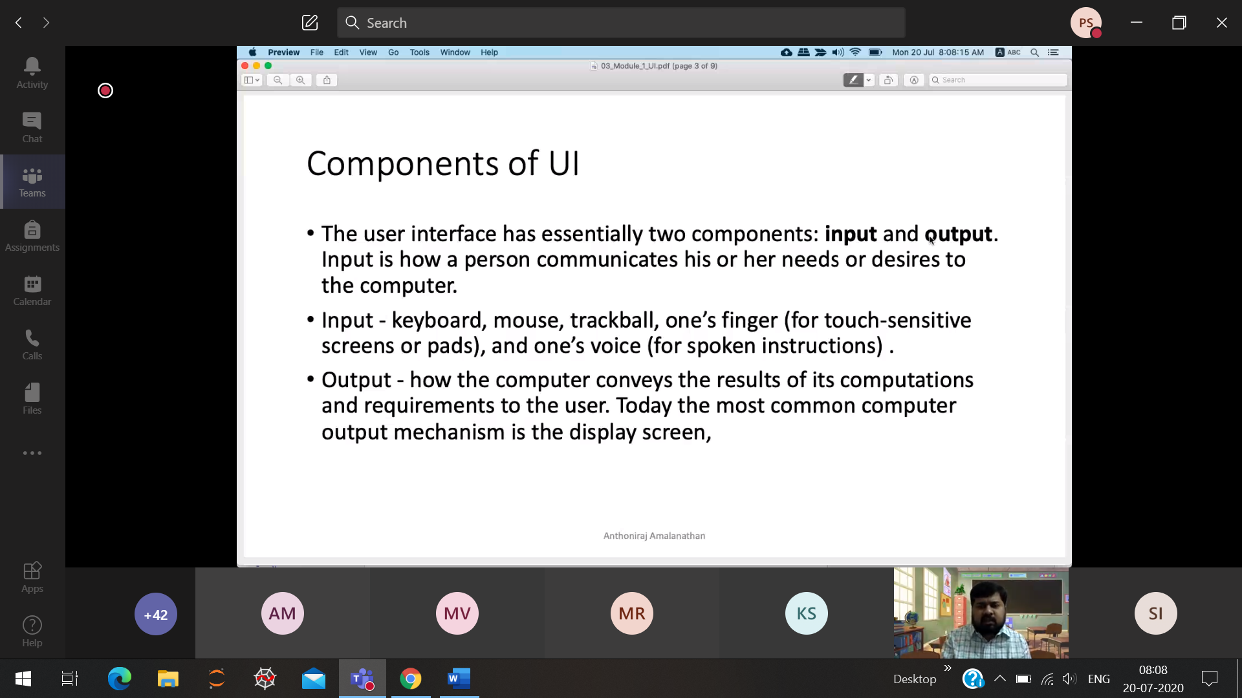

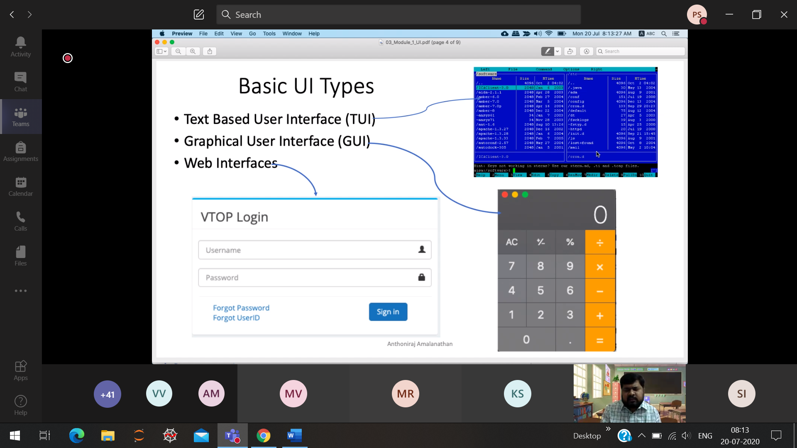

TUI 🡪 Only keyboard (direct interaction with OS) Midnight-commander

GUI 🡪 We can use keyboard, mouse, trackpad

WI 🡪

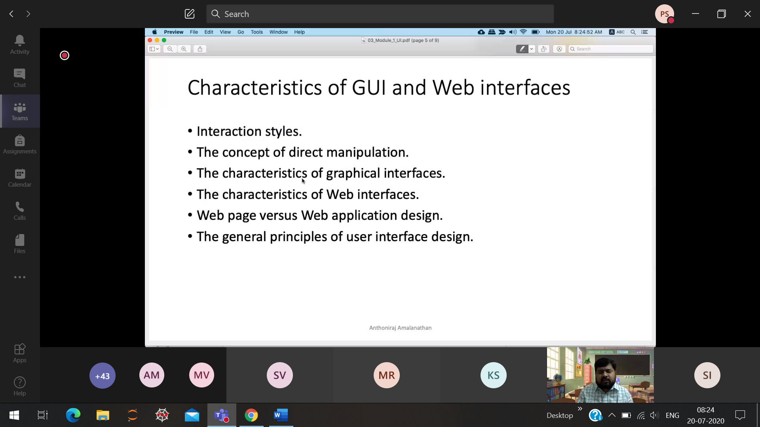

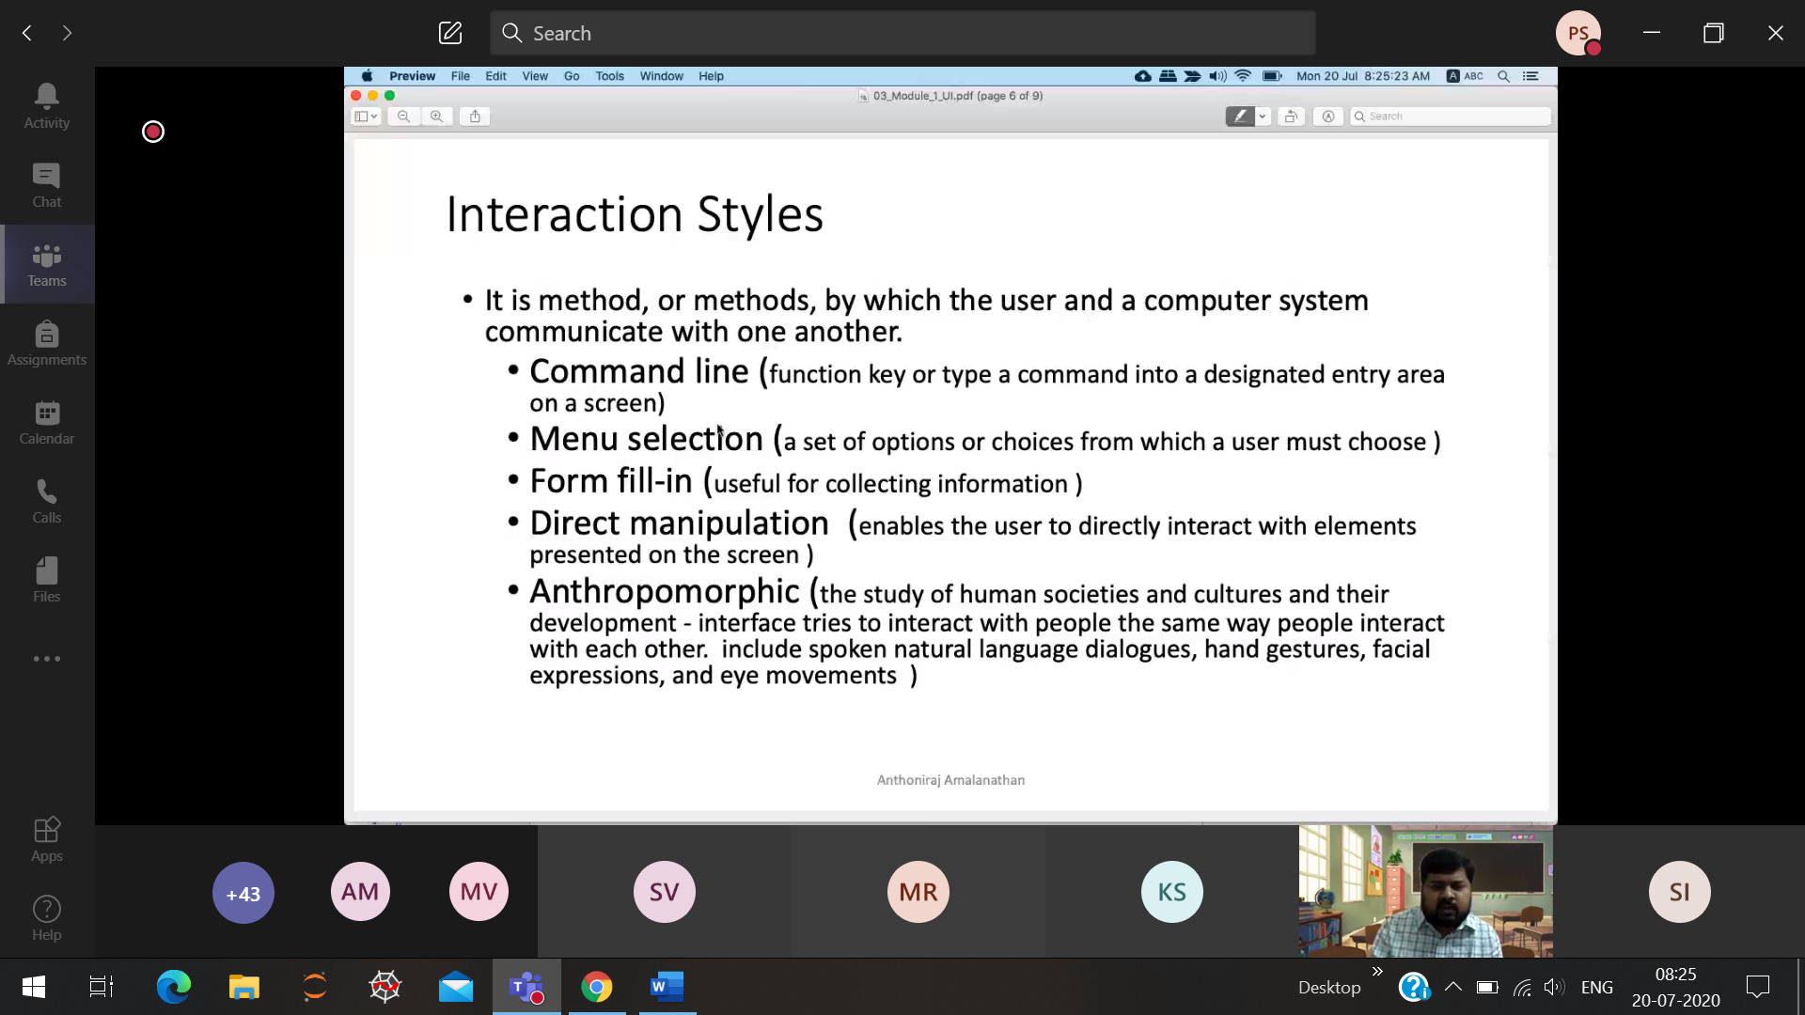

Direct Manupulation 🡪 Games

How we interact with the human beings, like that we are interacting with UI.

Based on the eye-retina movement, the webpage should be scrolled up and down.

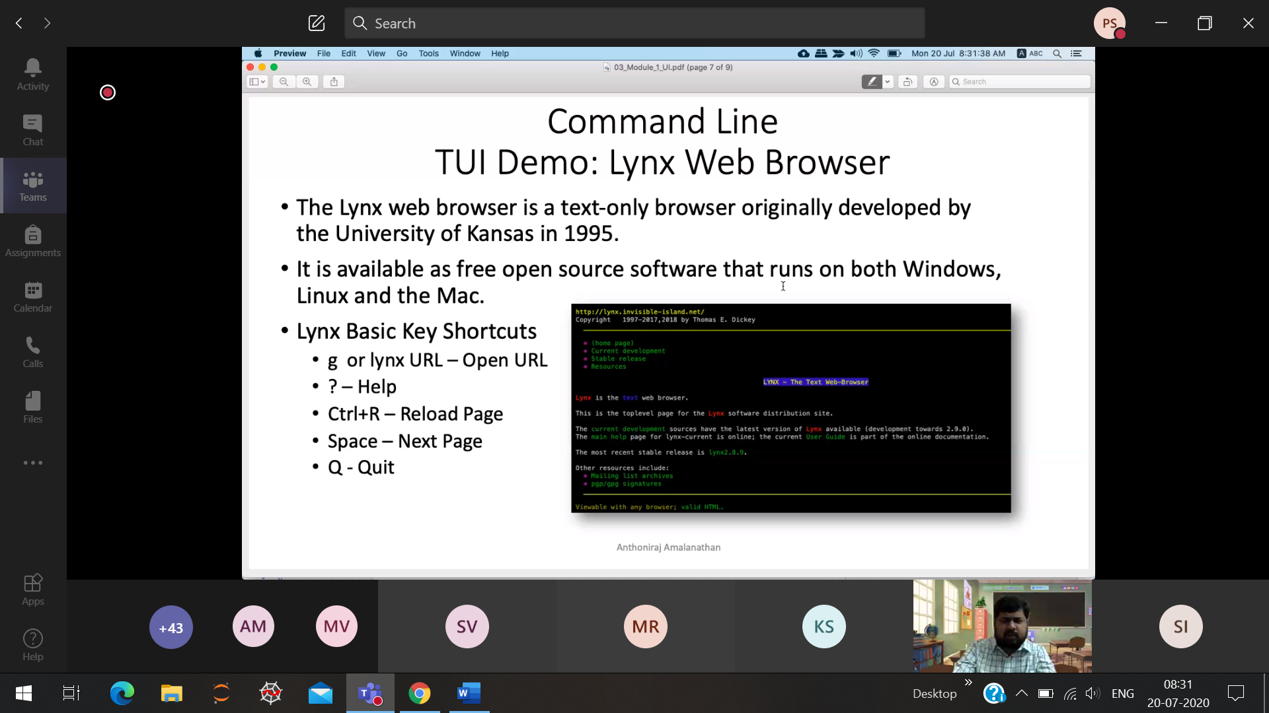

Lynx 🡪 comment based web browser

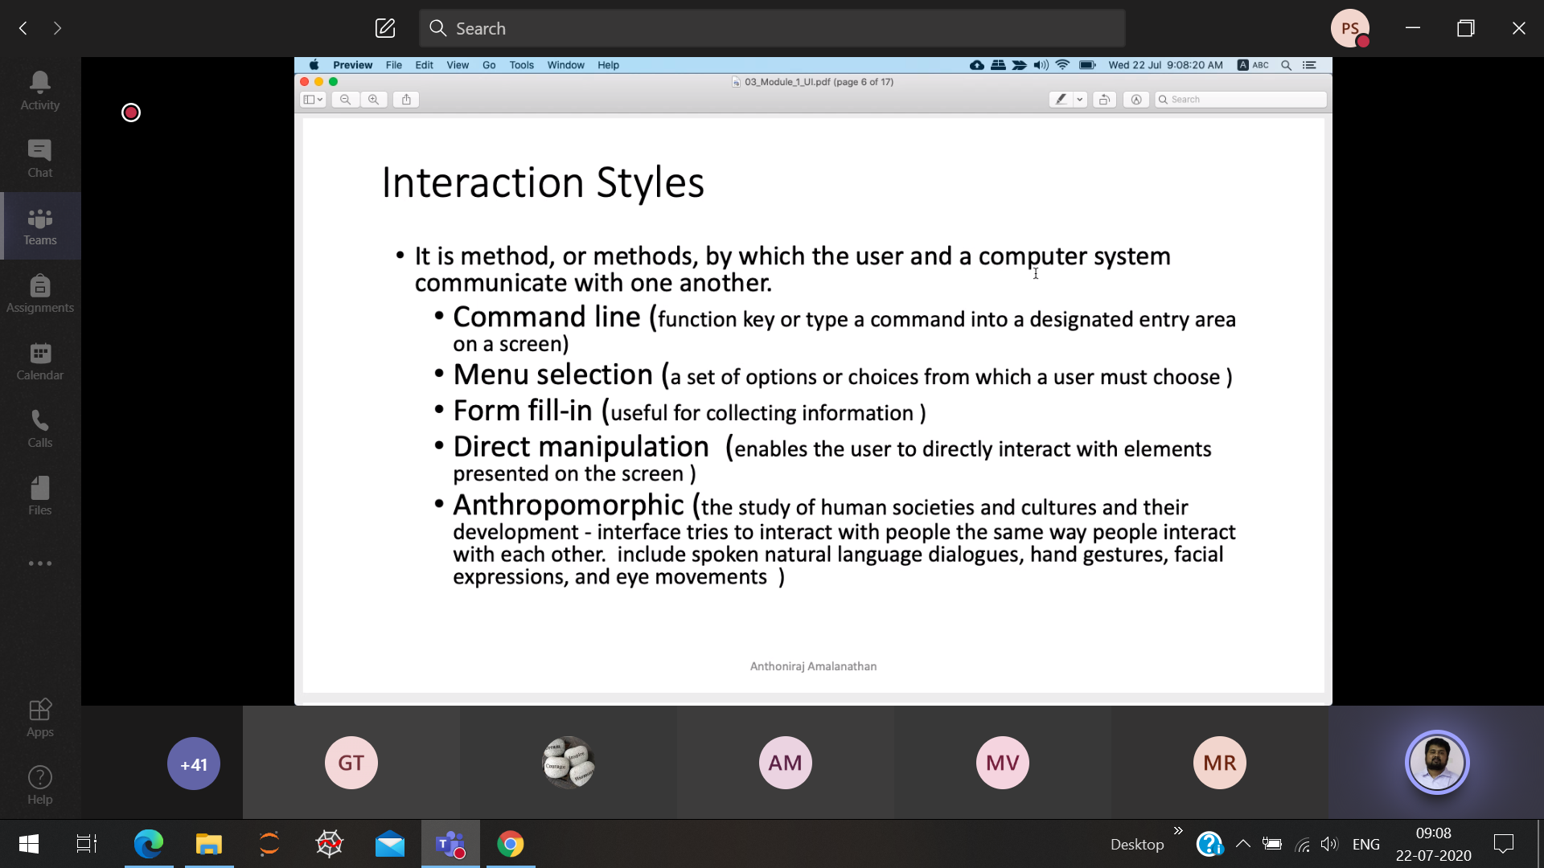

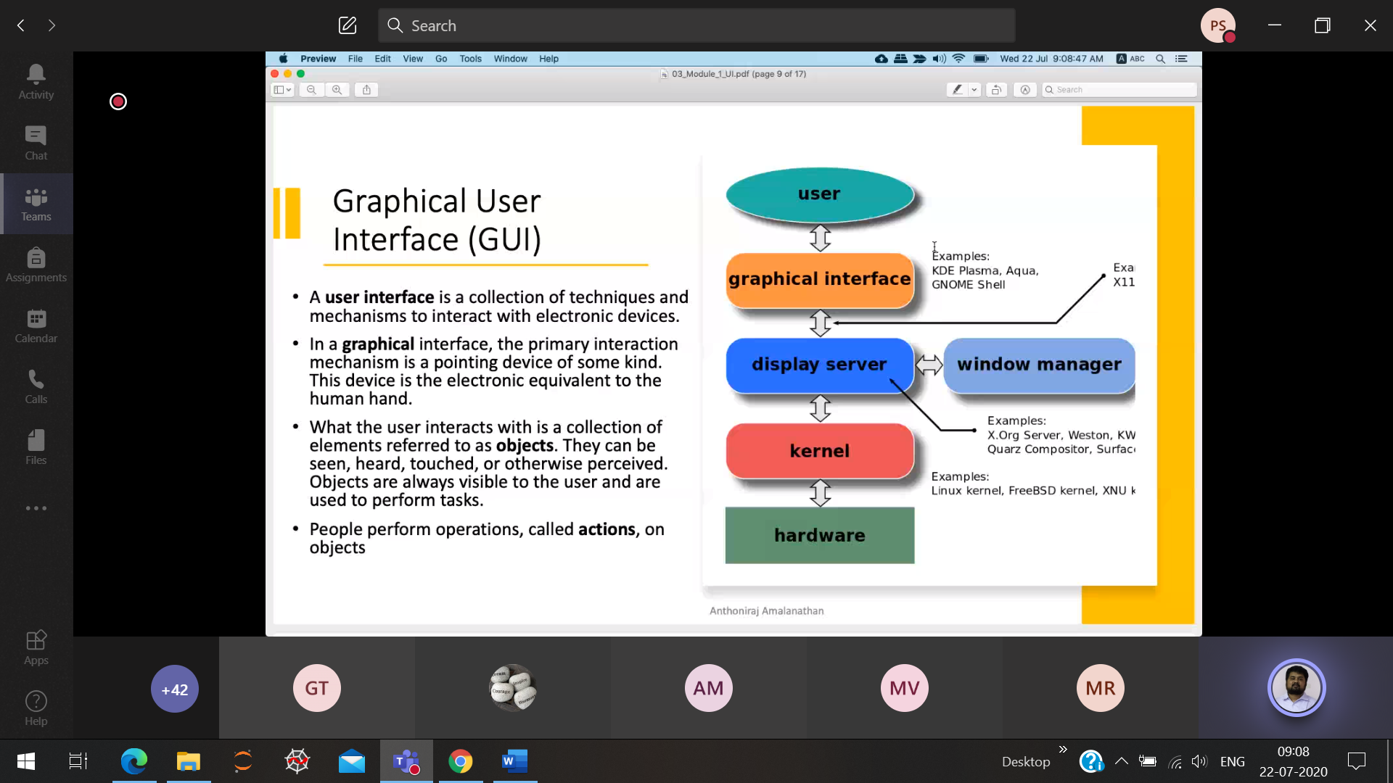

All the graphical elements 🡪 Object Will be replaced by TUI

Kernal 🡪 Core part of OS

TUI 🡪 directly interacts the Kernal and then into hardware

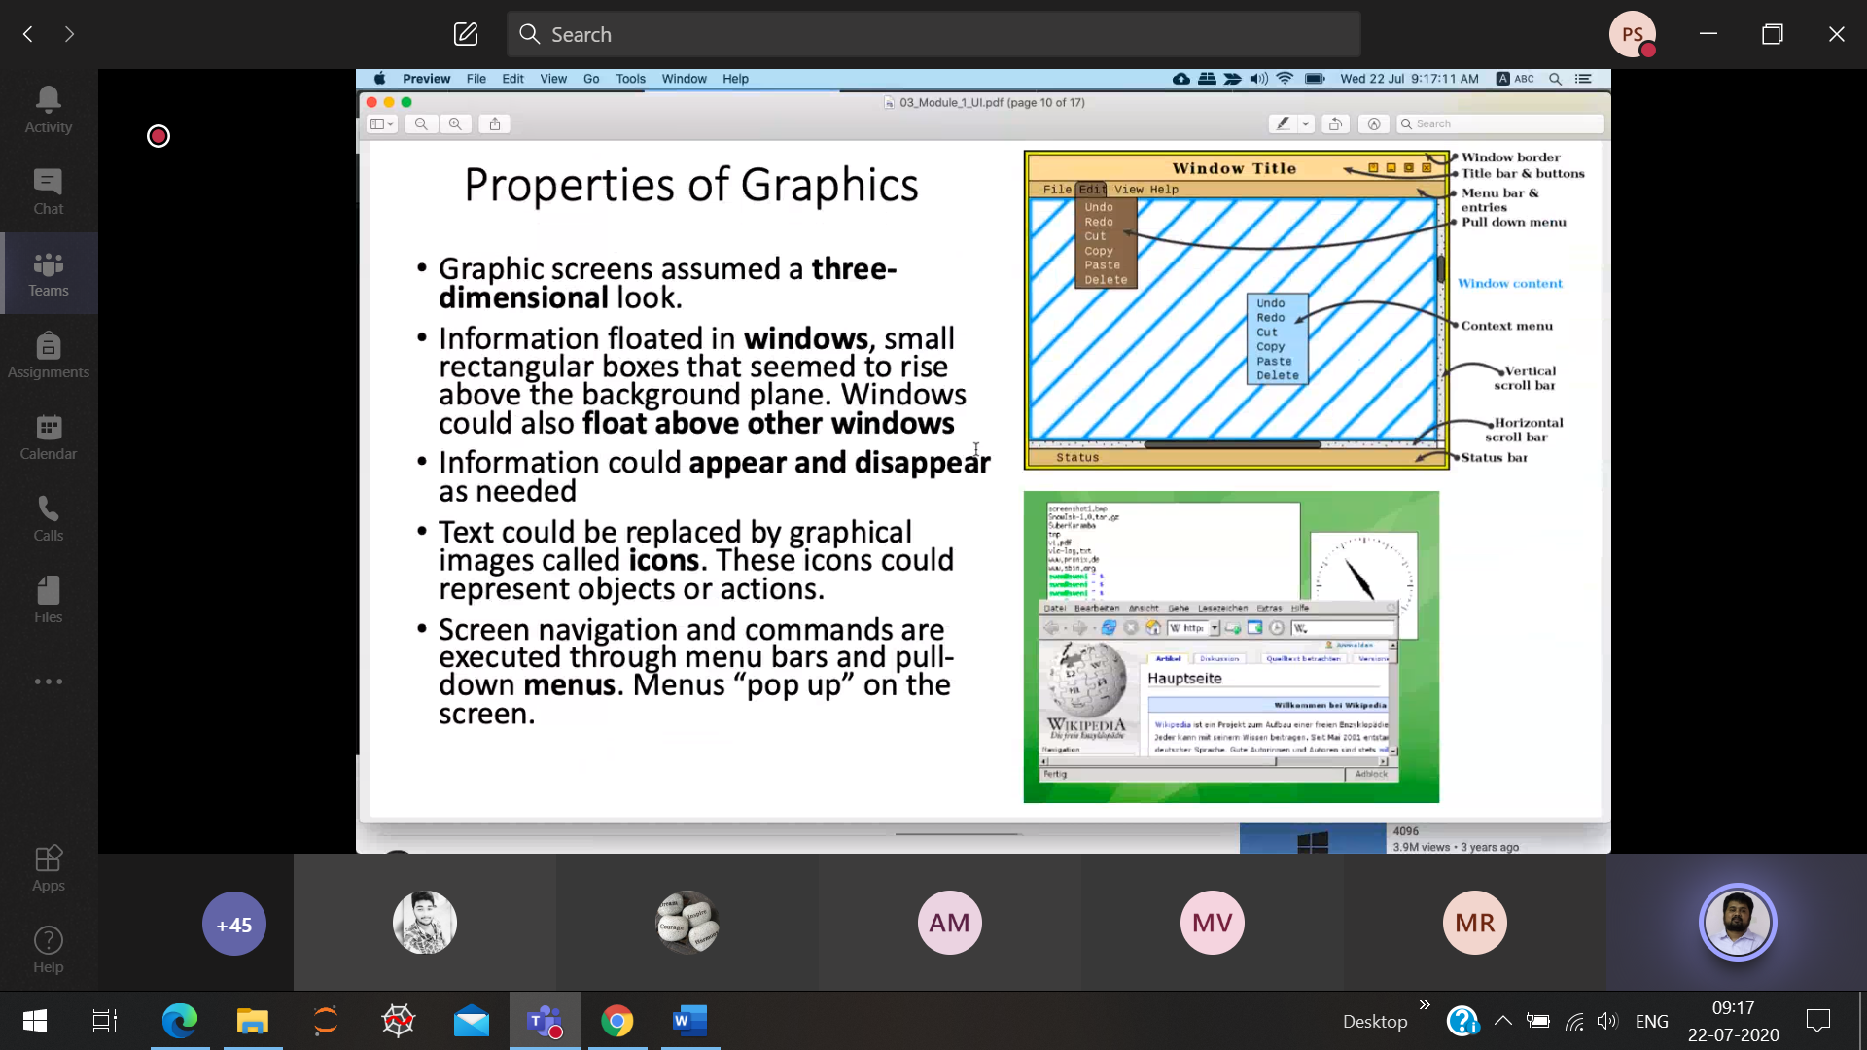

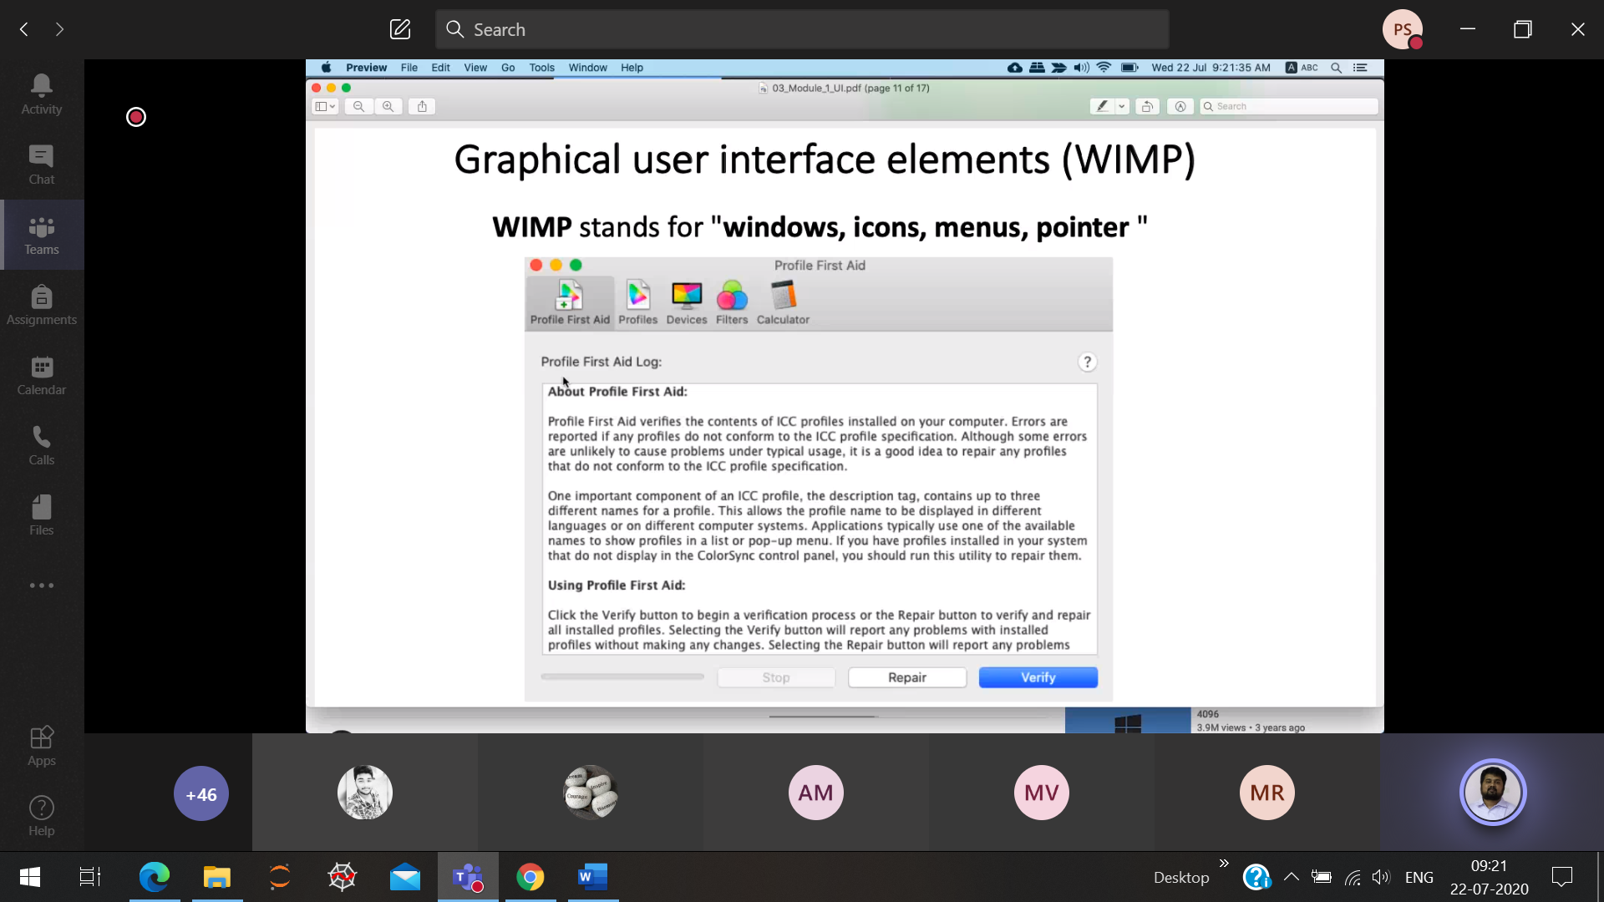

Pointer 🡪 used to point/touch the elements of the object . Eg: Joystick, touch, stylus

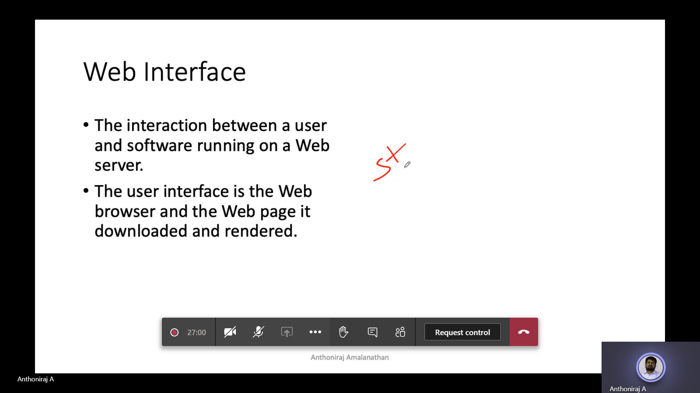

Standalone application web application text,audio,video,animation

Installed not installed

PHP  
CSS  
Javascript

Parser reads the HTML code to the human readable form

Parser 🡪 Webkit (html code 🡪 human readable form) is a browser engine which transforms

Web page , web browser,

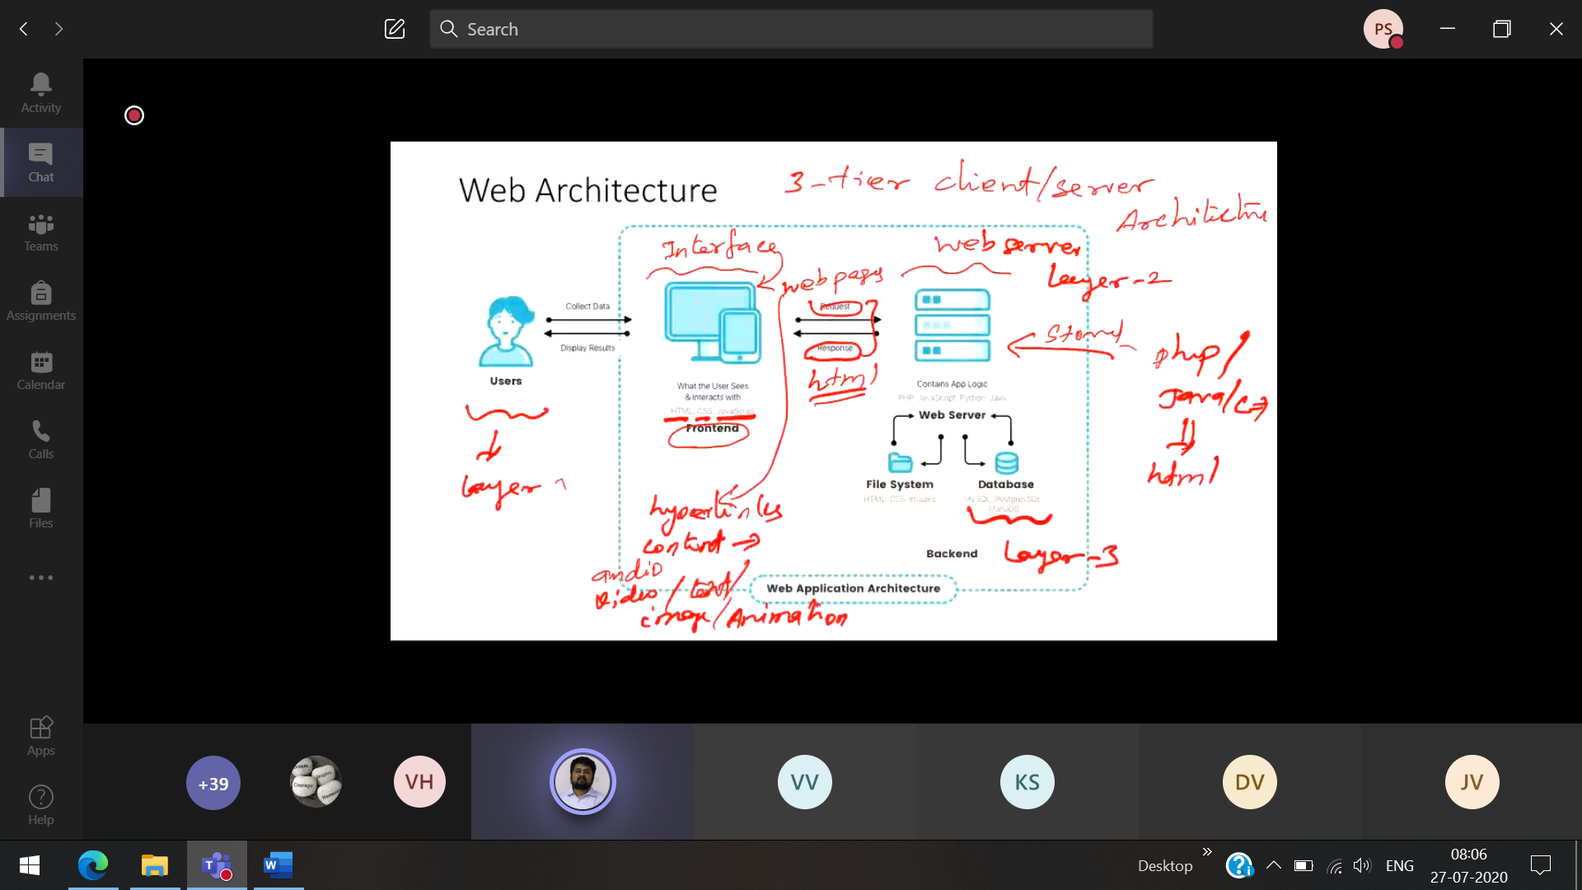

Layer-1 User

Layer-2 web server

Layer-3 Backend ( File system , data-base)

Web-site and web-page 🡪 Same

Web-browser 🡪 Chrome, firefox

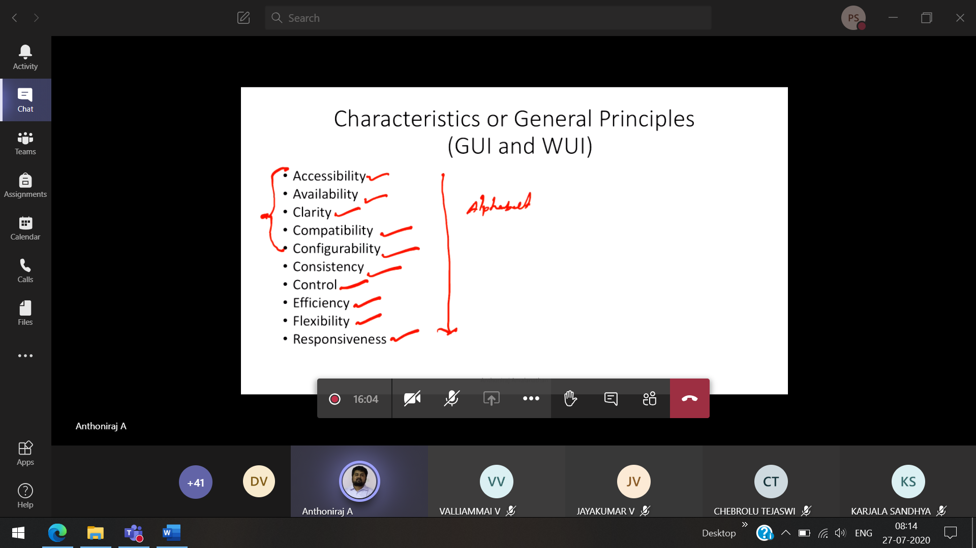

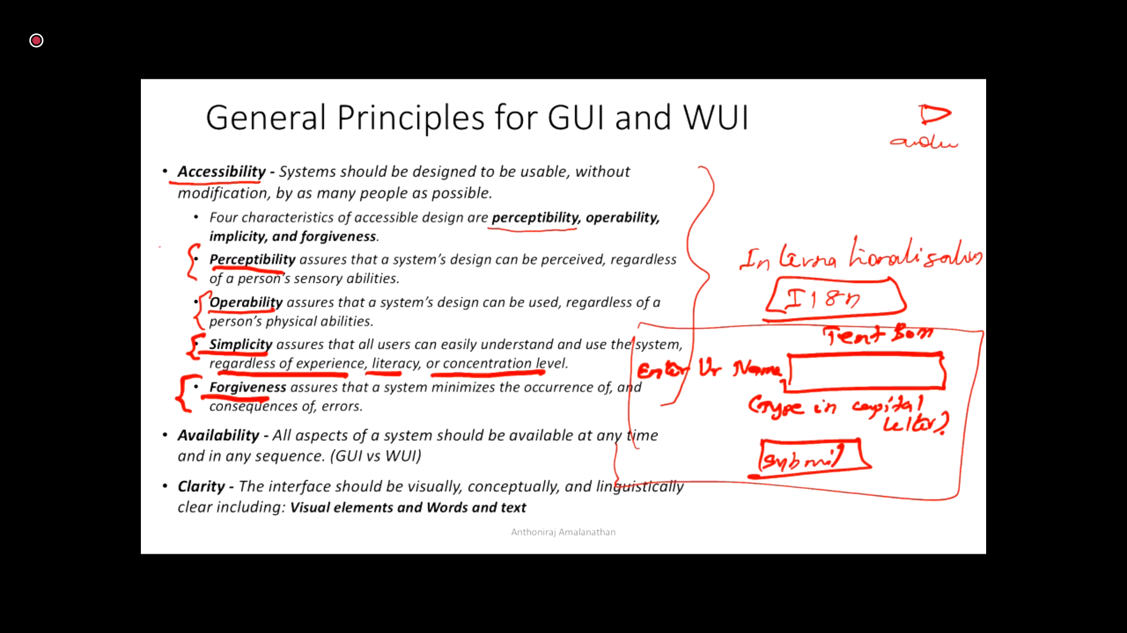

Internationalization 🡪 I18N

Perceptibility 🡪 Anyone can operate the

When the user types in small letter, java-script will convert into caps and store it.

**Availability**

1)Internet connection  
2) Server availability

**Clarity :** Don’t use unfamiliar words like “save” and “store”

Mobile phone : JSON  
PC : HTML

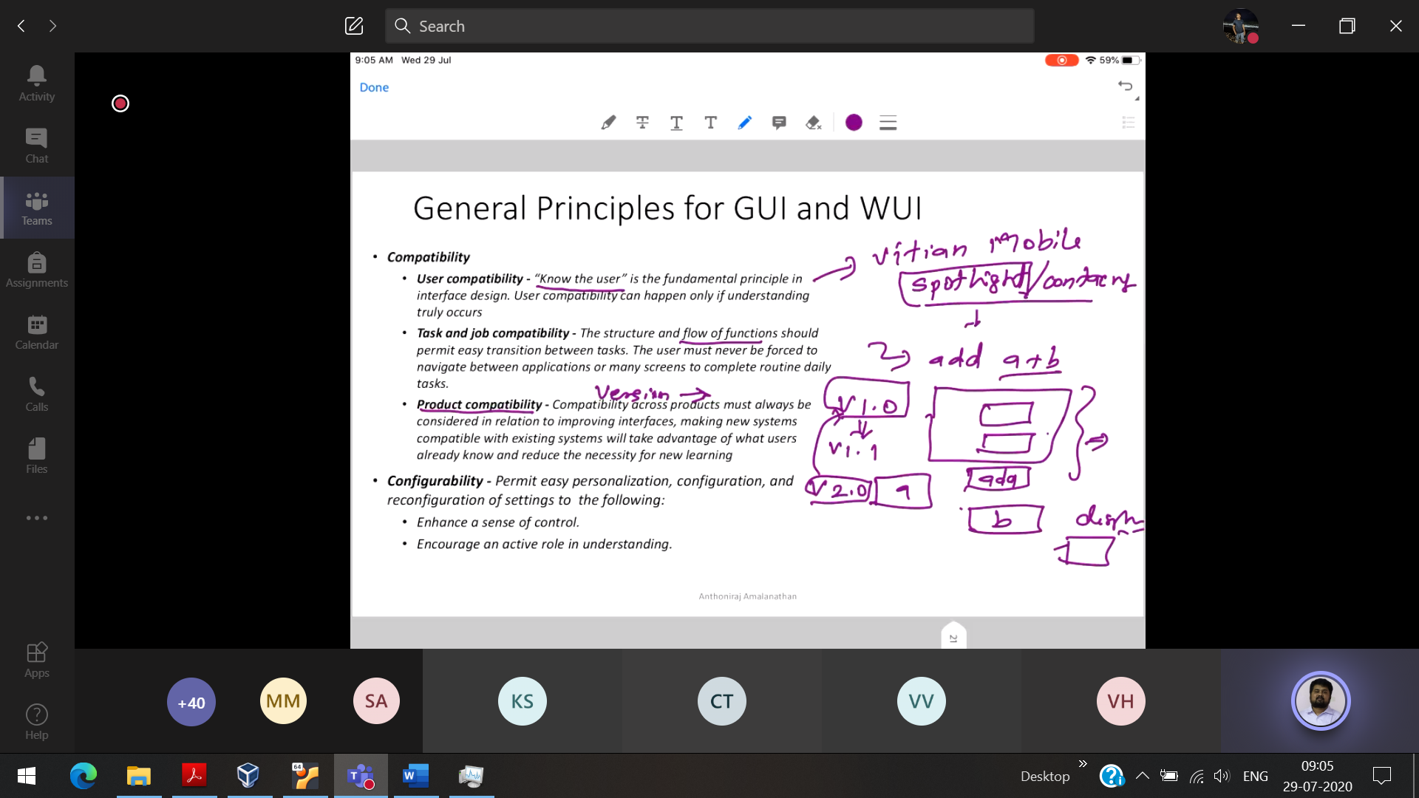

Personalisation : FB, 1st user gets one particular content whatever they config Same URL  
 2nd user gets another particular content whatever they config



Enhance the sense of control 🡪 User can block/hide/unfollow when the content is not relevant to the user.

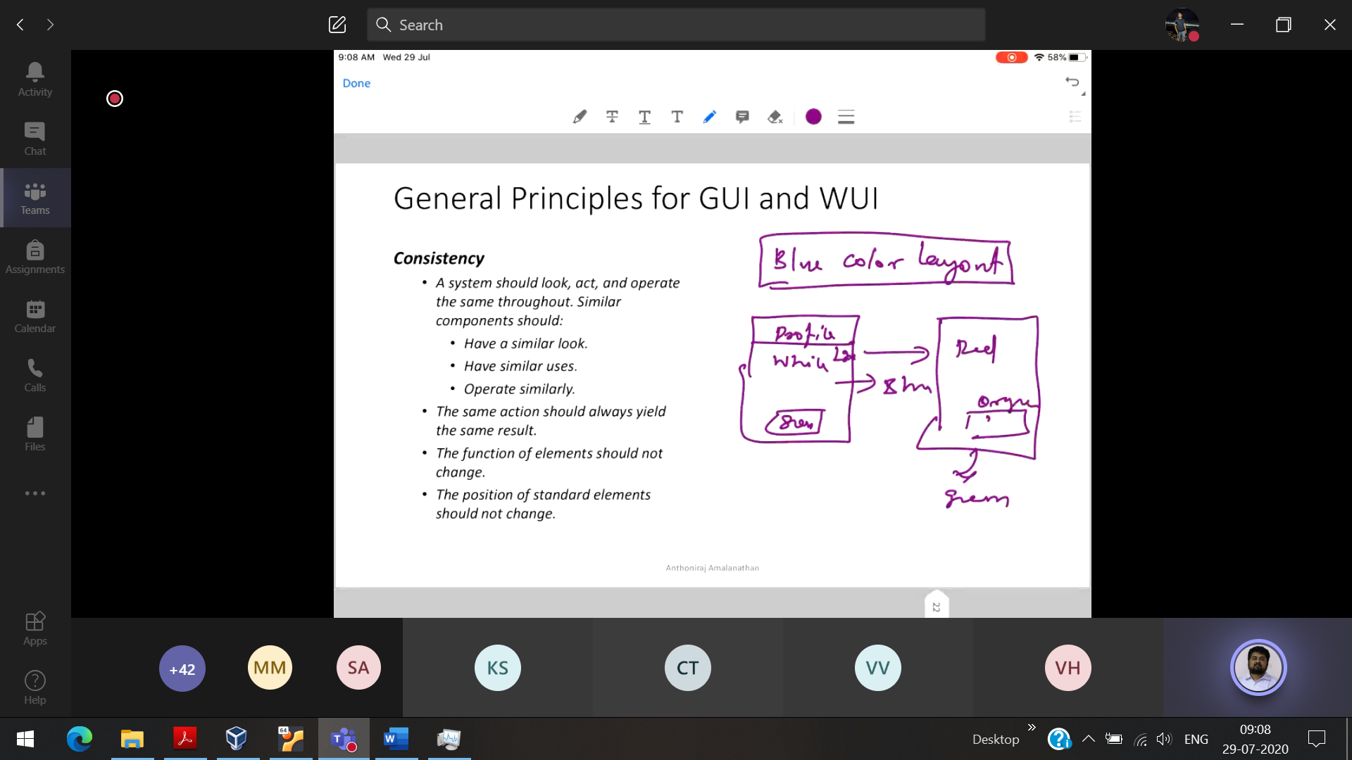

1st page 2nd page

Blue color background Orange color background

Similar look : Should have similar uniform pattern like font color, background color, shade of the webpage

Similar uses : All the buttons should perform the same function in all page

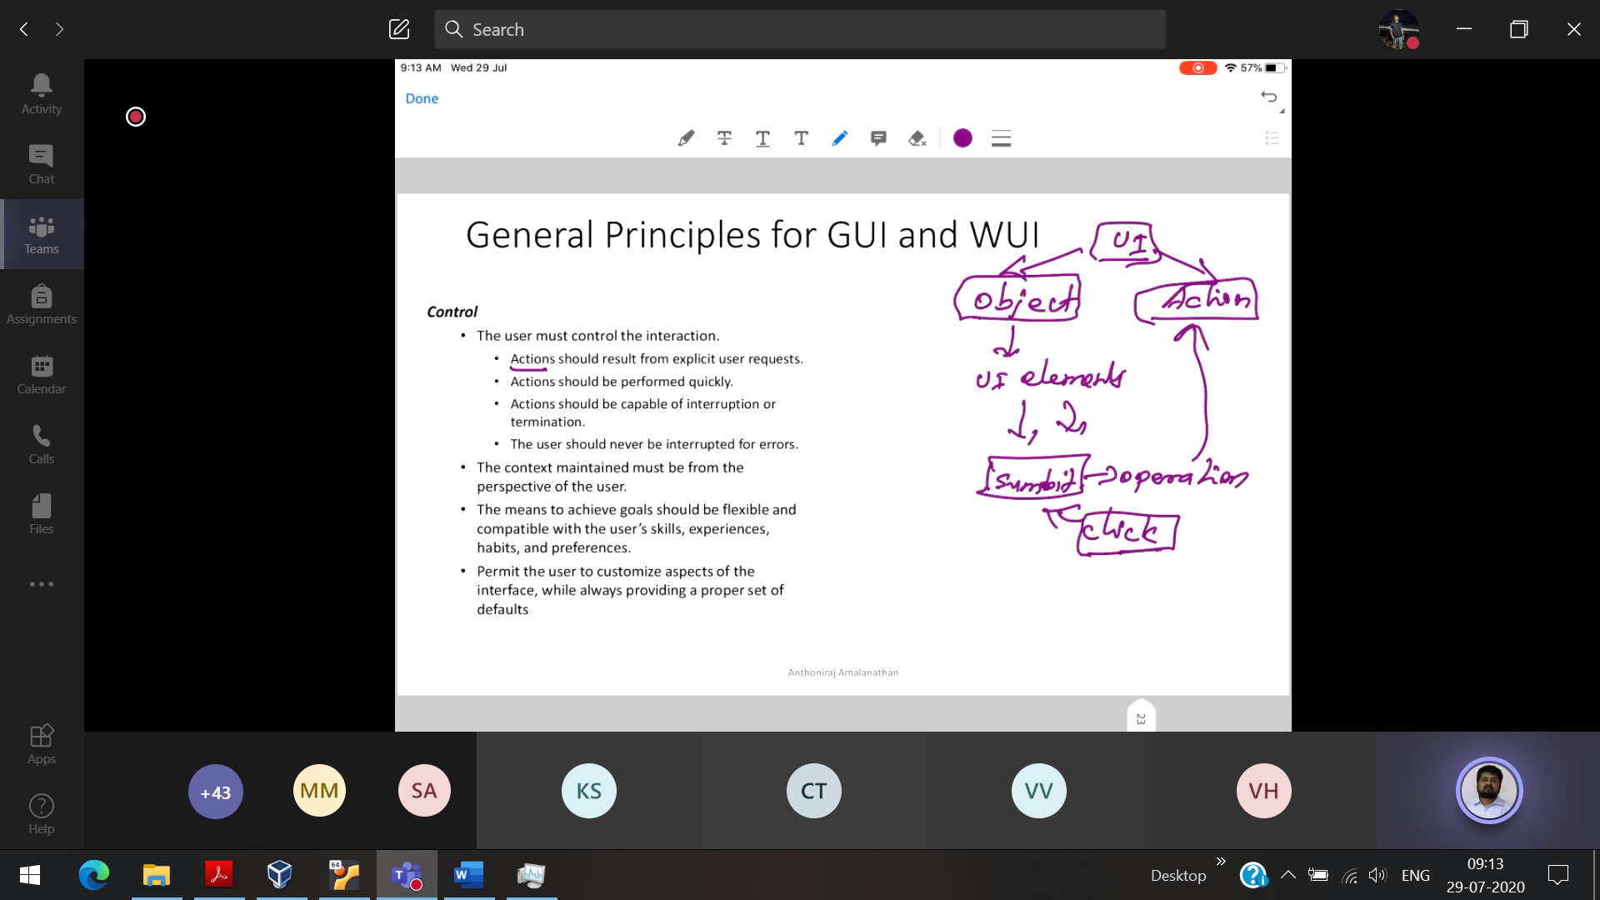

UI element : Submit button , when we click then that is the action

User can terminate/interruption

Eg: Want to send an attachment, but we are foregetting to send.  
If in my mail , I write “Pl refer the attachment” 🡪 Gmail uses ML algorithms and prompts to attach the file when we click send.

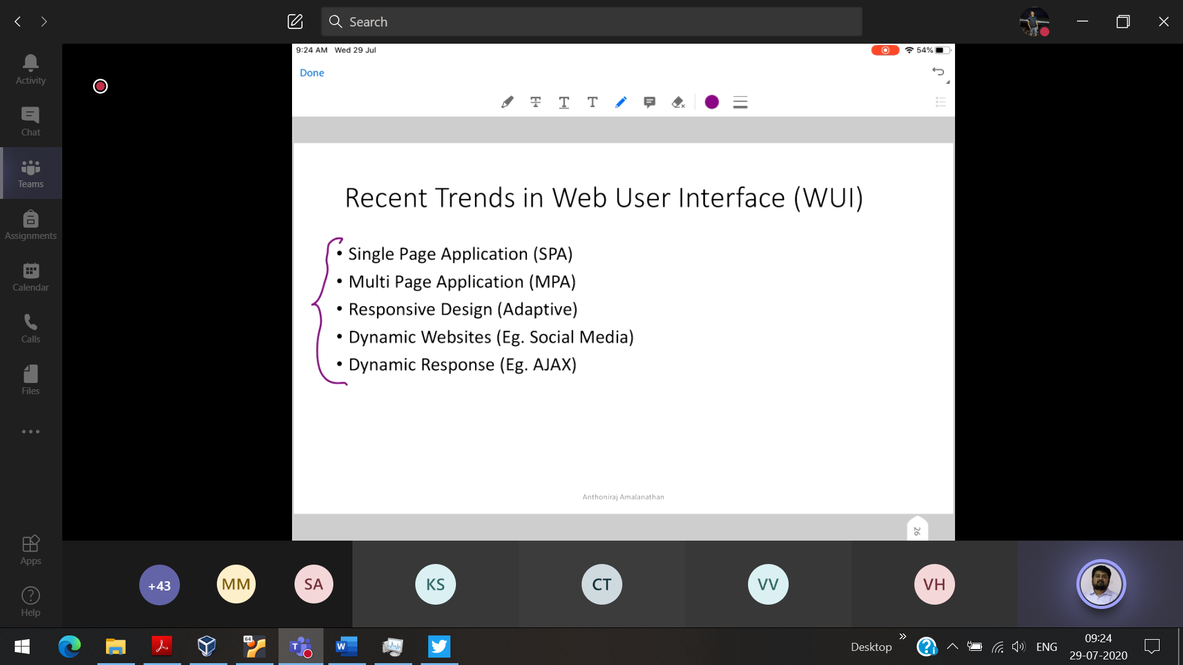

Responsive design 🡪 All the web-sites should be adapted to the screen size of tab,mobile,pc

AJAX 🡪 When searching for a web-site, it will recommend some related web-sites, the current web-page will not re-load and shows recommendation.

But in Wikipedia, when we click hyperlink the page will be re-loaded and goes to the new-one, it hides the page which we have searched.

Chapter – 2

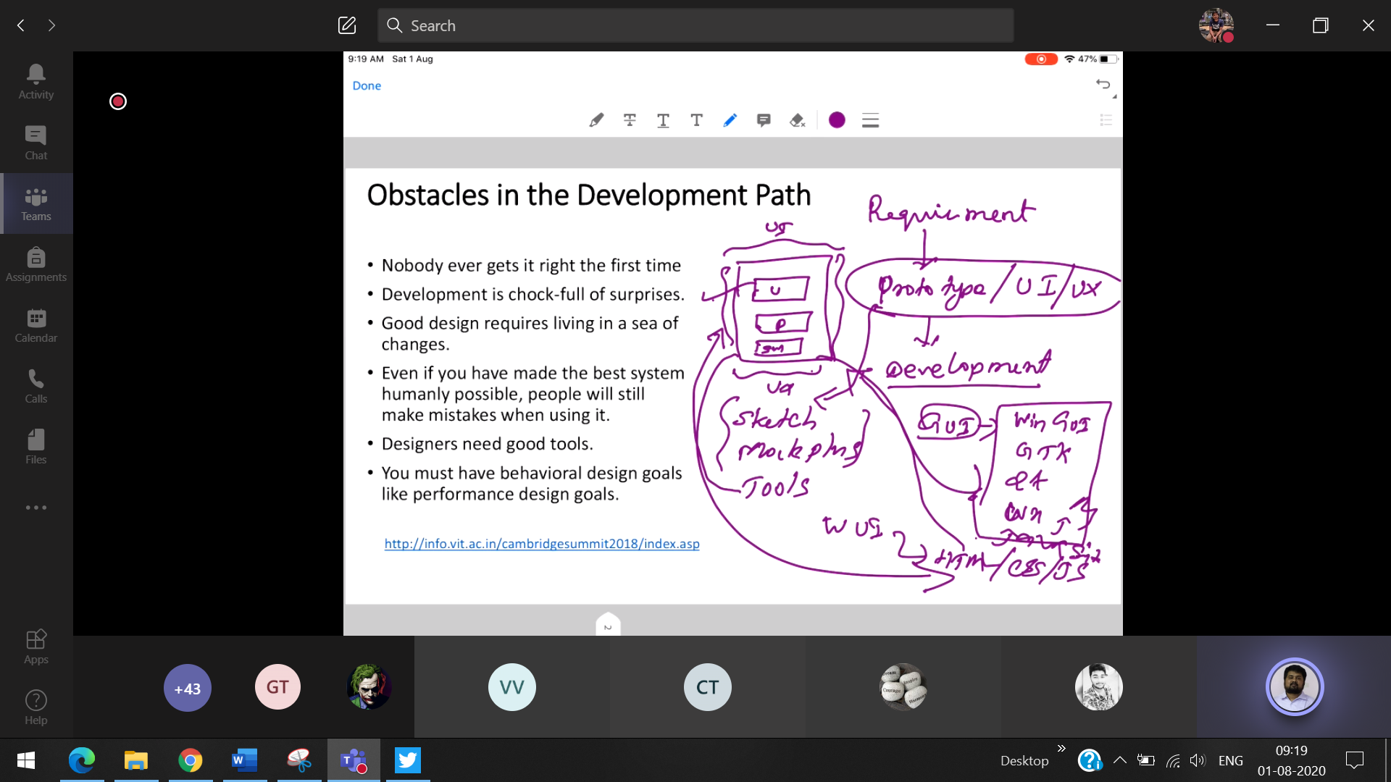

Tools to create the prototype for UI

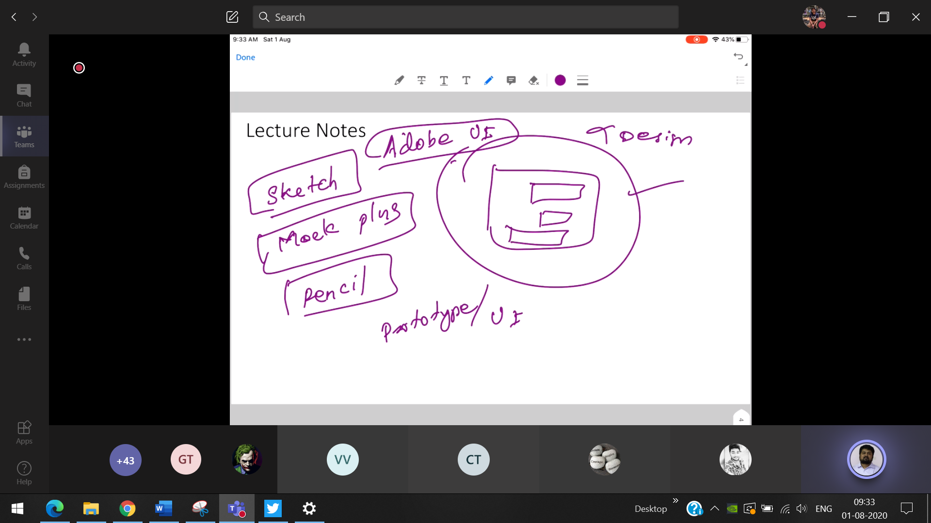

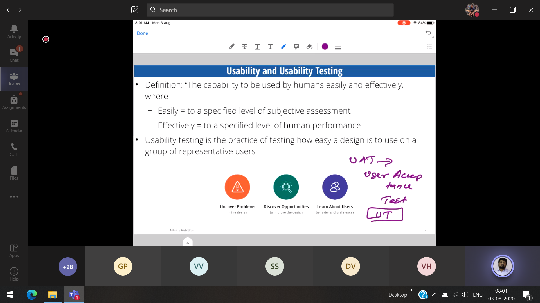

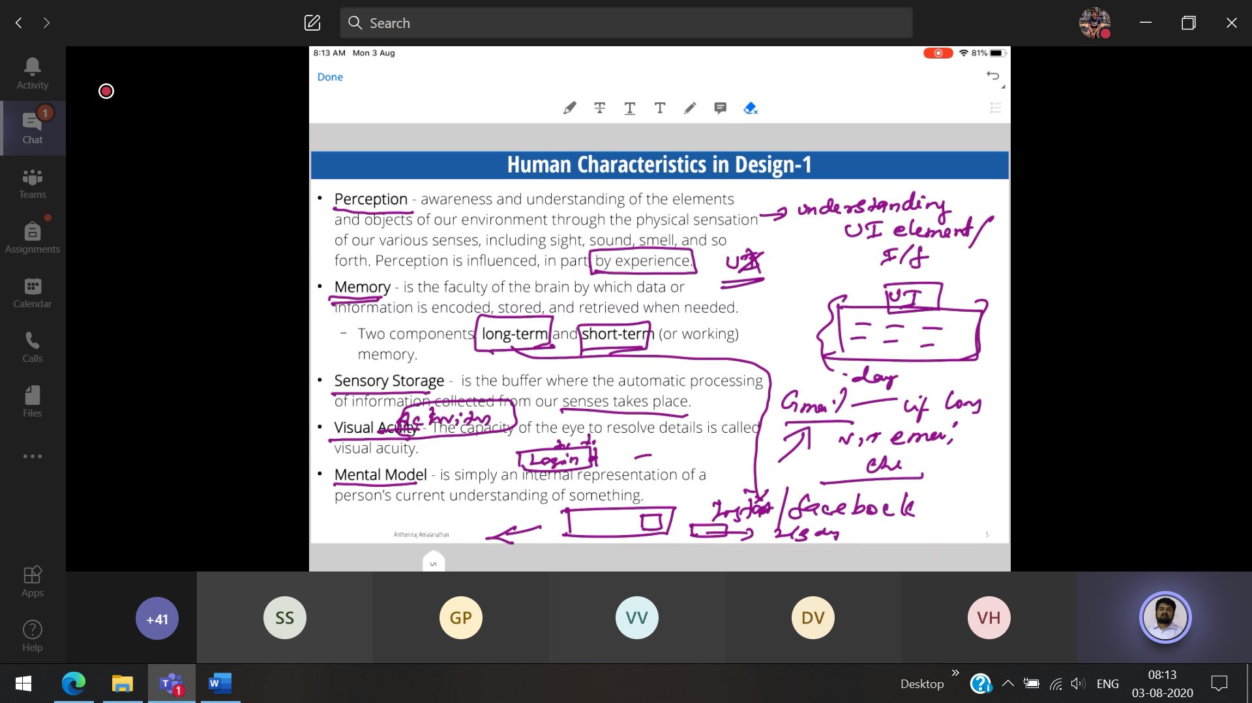

Mental model : Login Reset (When they are too close to each-other by mistake, the user will click reset instead of login



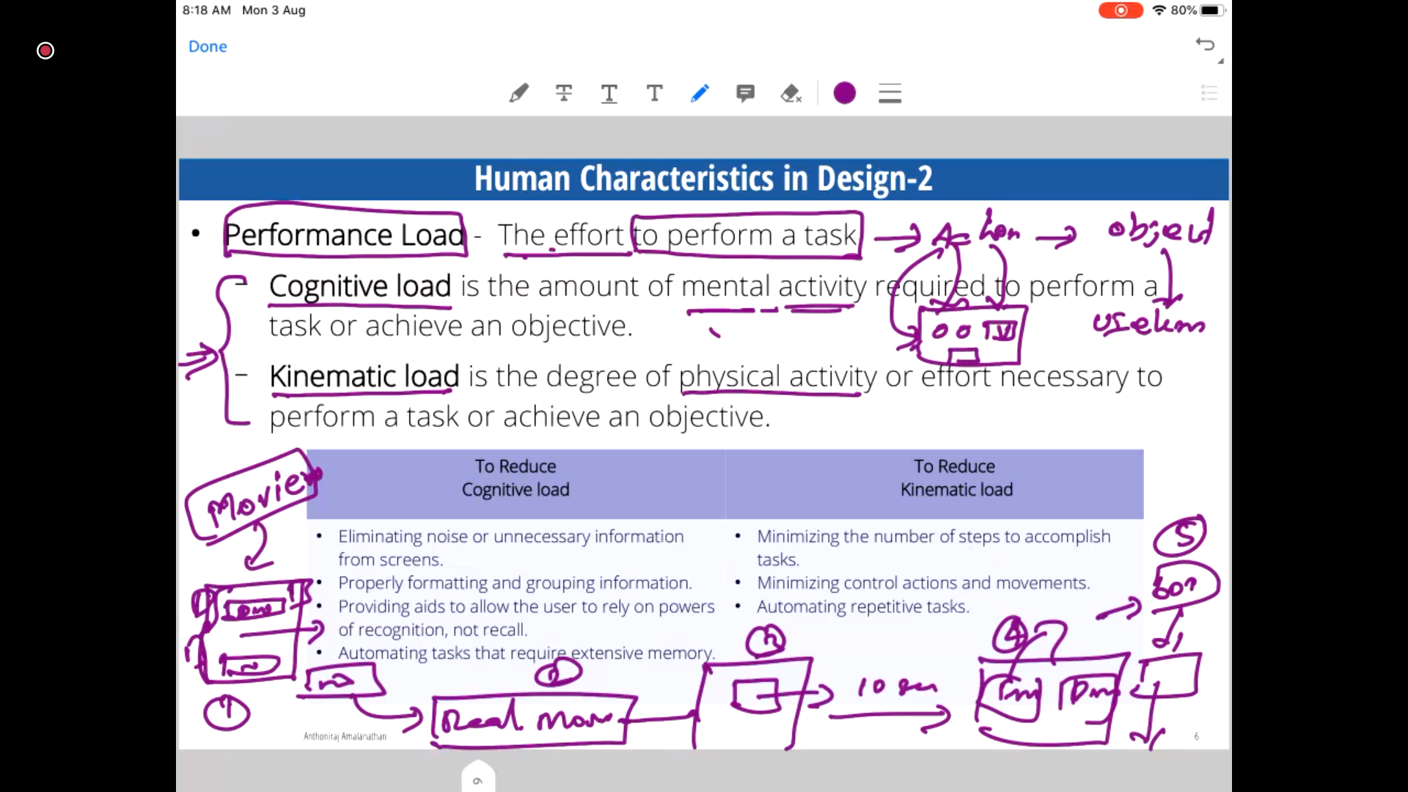

Eg: Movie download

Mental activity 🡪 The user finds the link where to download among (3 download link)  
Physical activity 🡪 Clicks 1 link then it will go to another page(ADD 🡪 5 seconds) , loading going upto to 3-4 pages and finally getting the download link

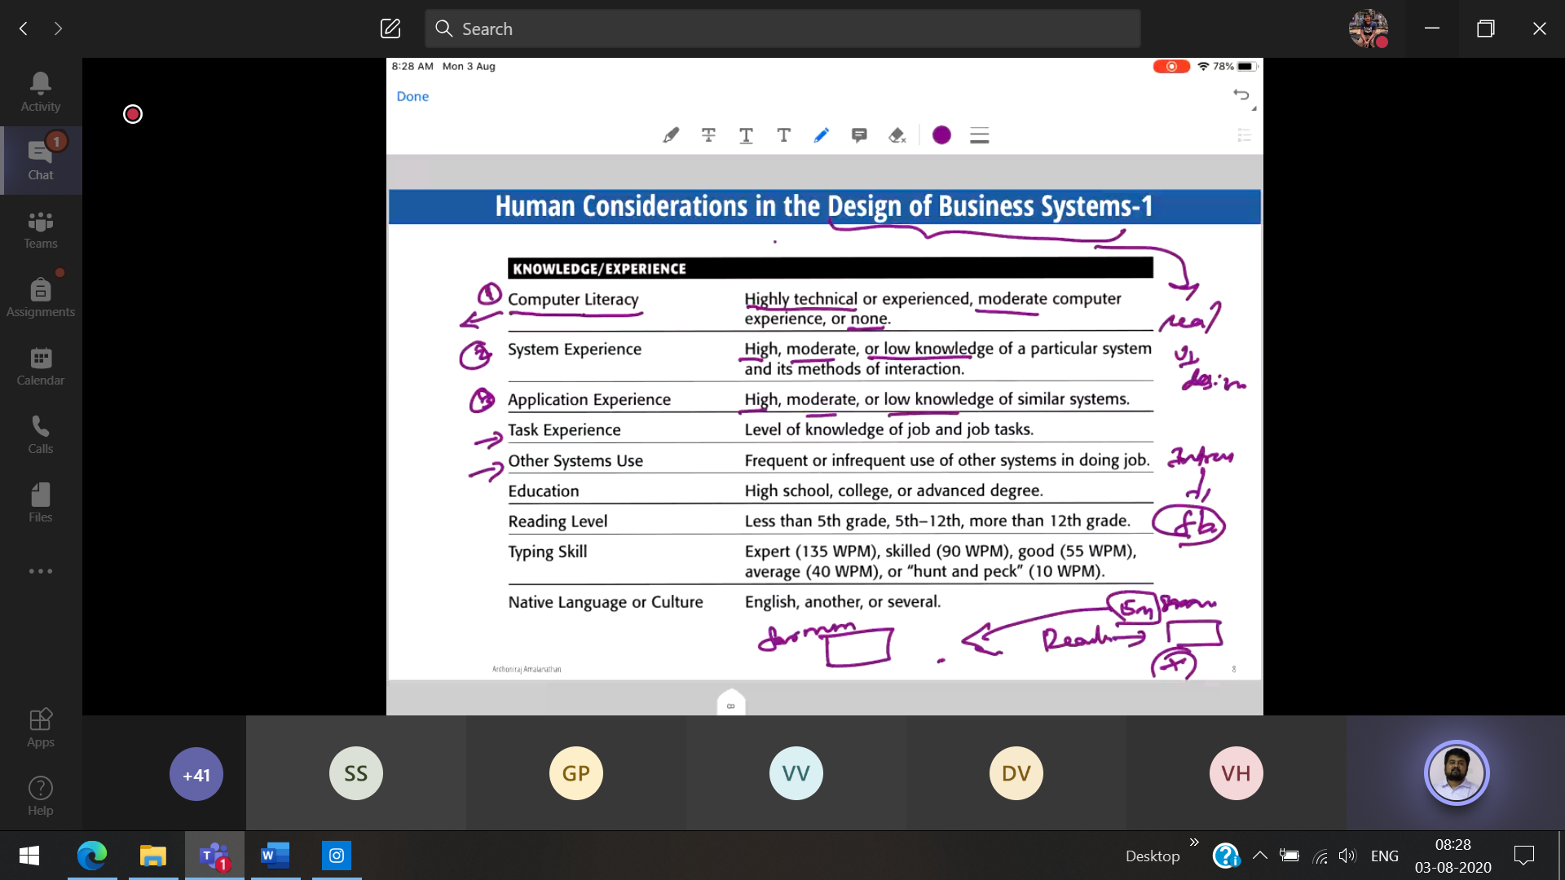

Forum (vs) email

WPM 🡪 word per limit (ML algorithm which helps the user to autocomplete the word)

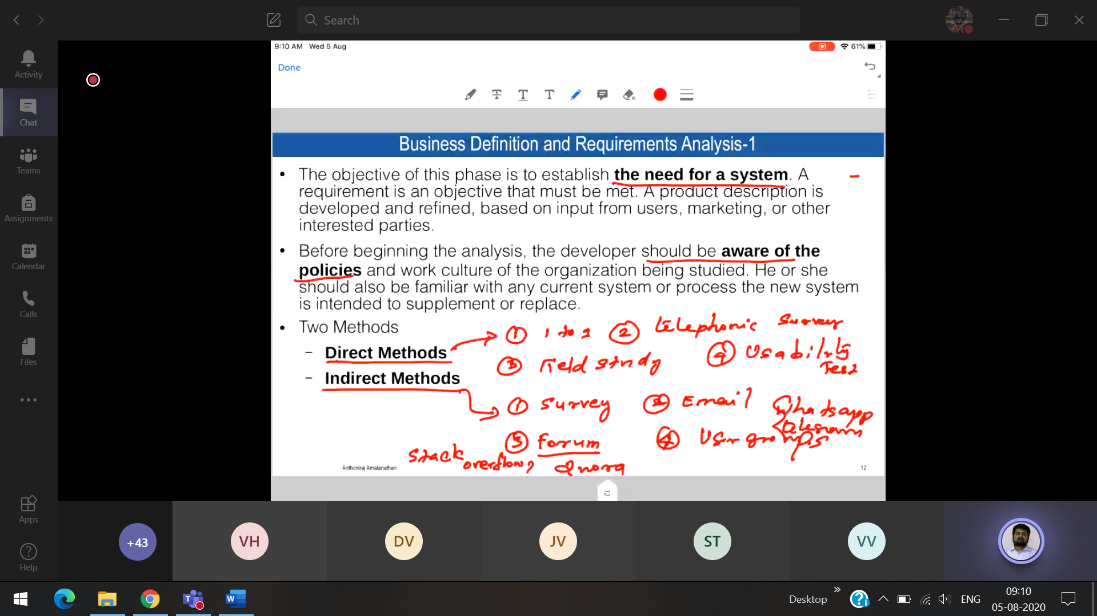

Forum 🡪 Stack Overflow, Quora   
User group 🡪 FB, whatsapp

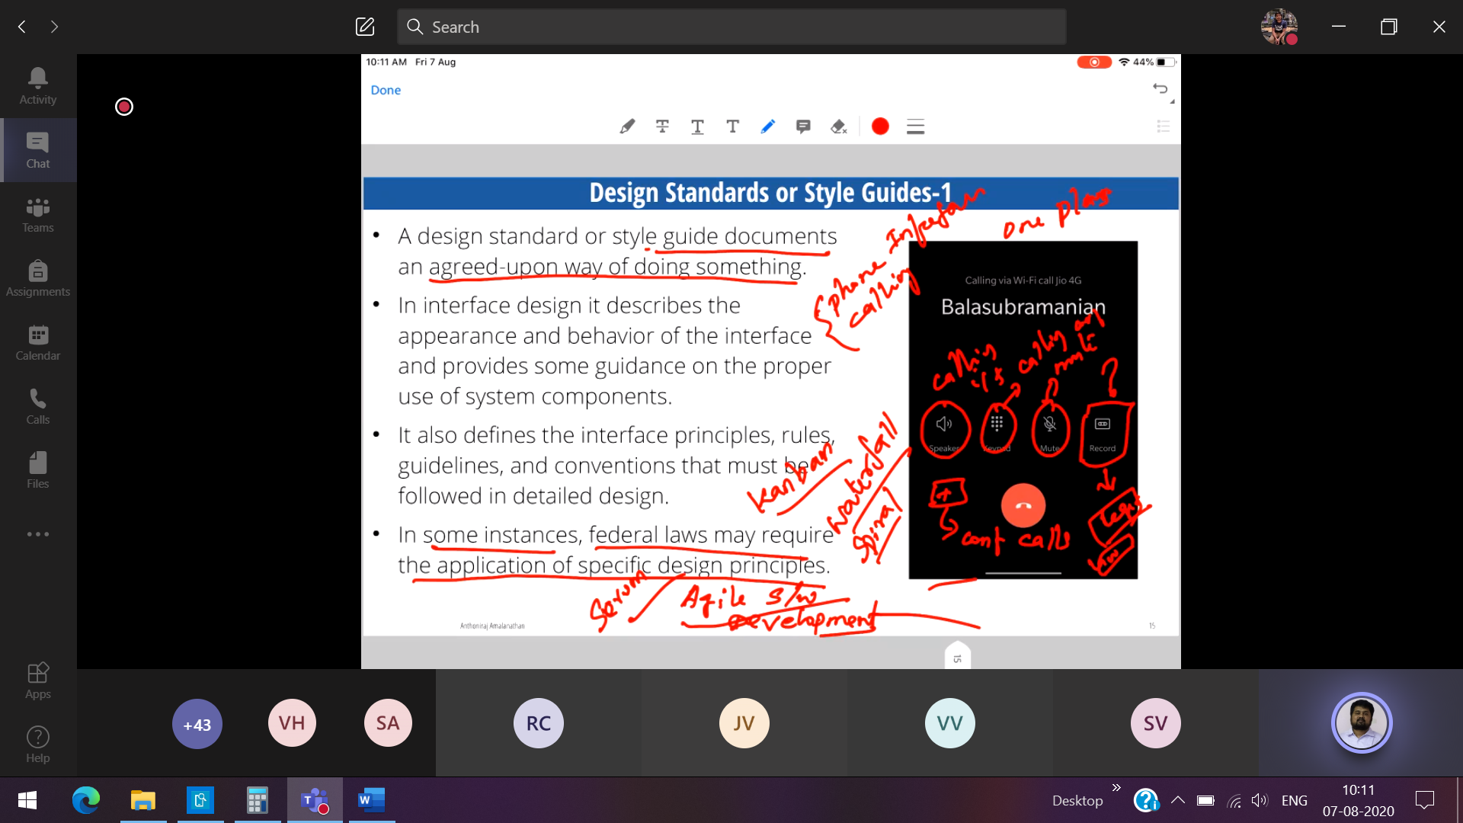

Record 🡪 Not allowed in US [ So no record button in iphone]  
But allowed in China (So only oneplus phone has)

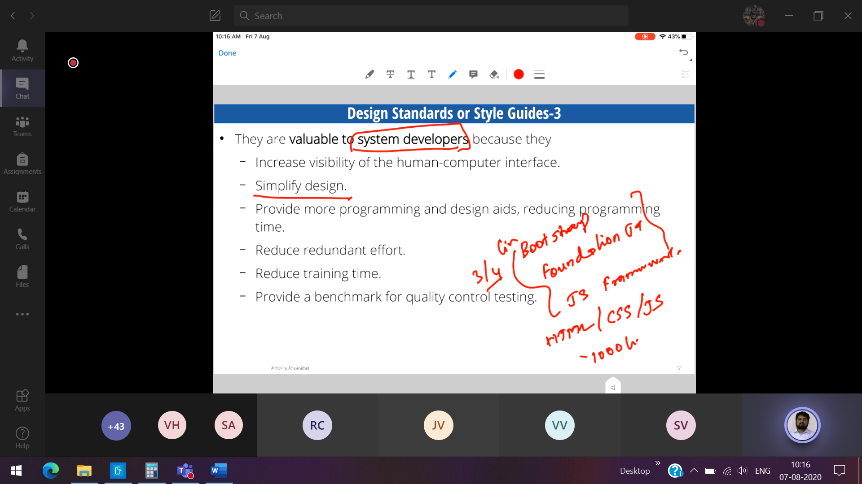

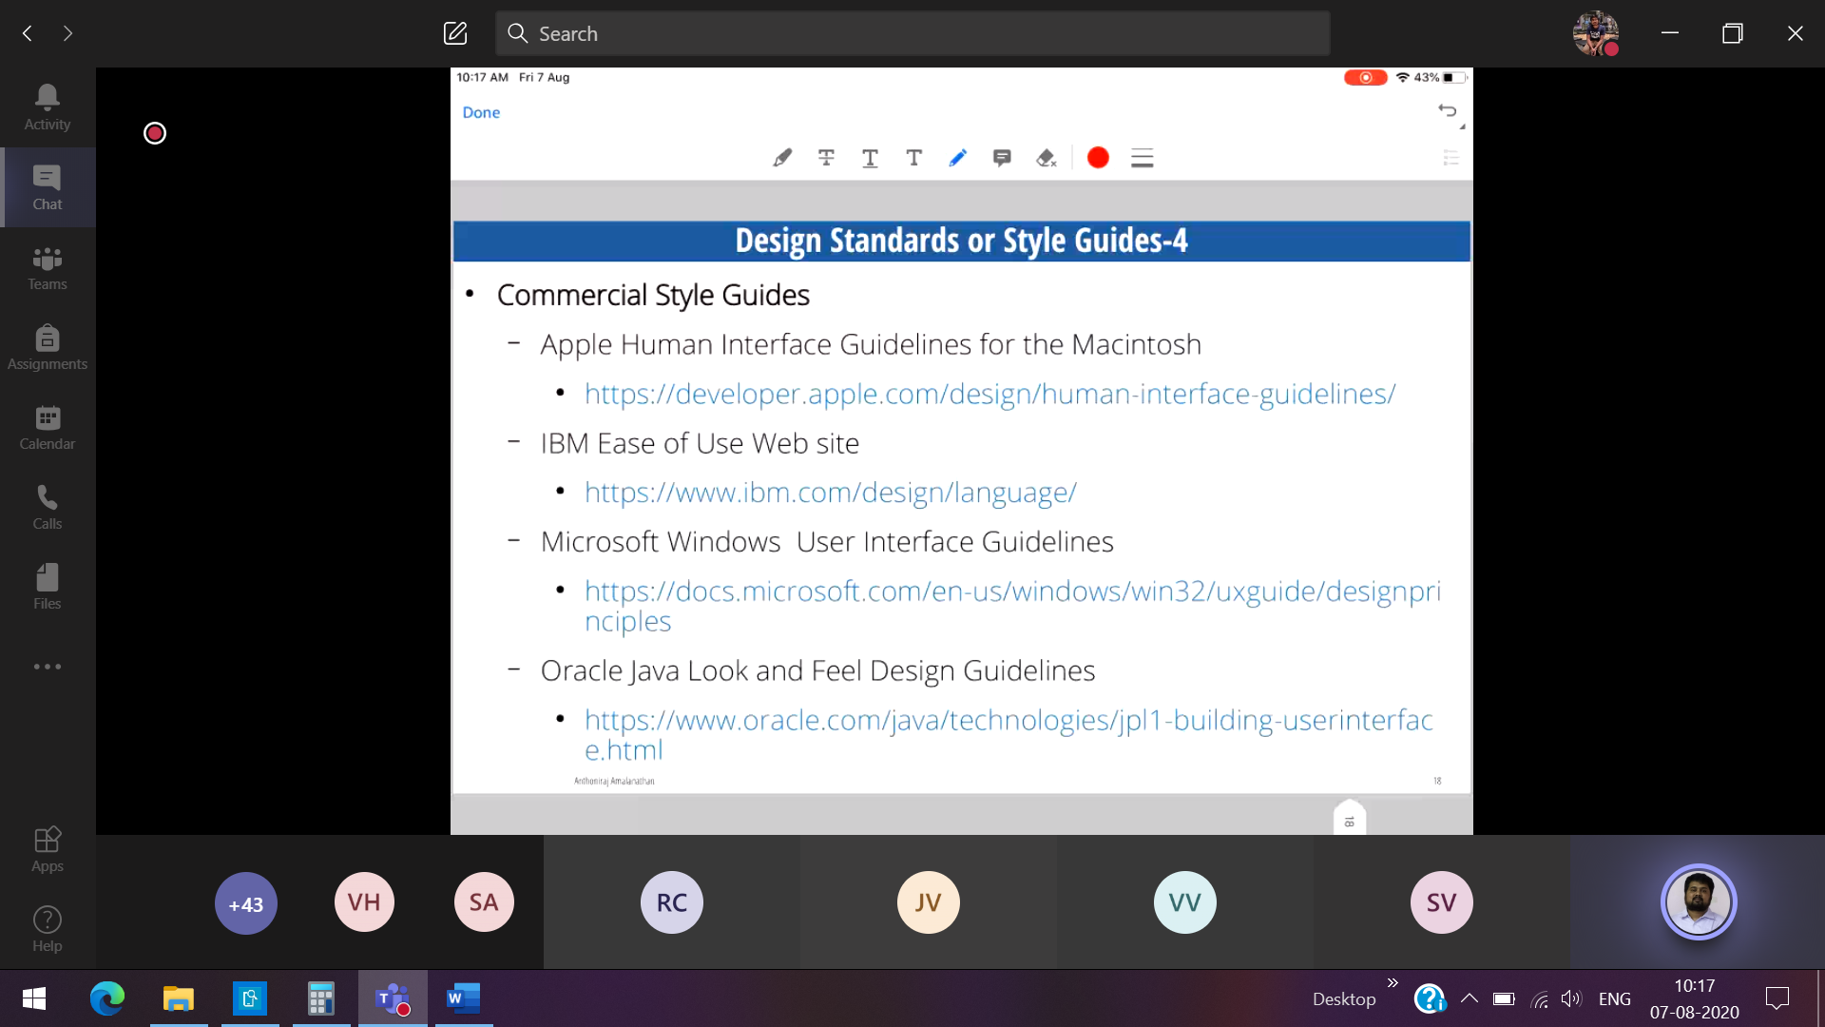

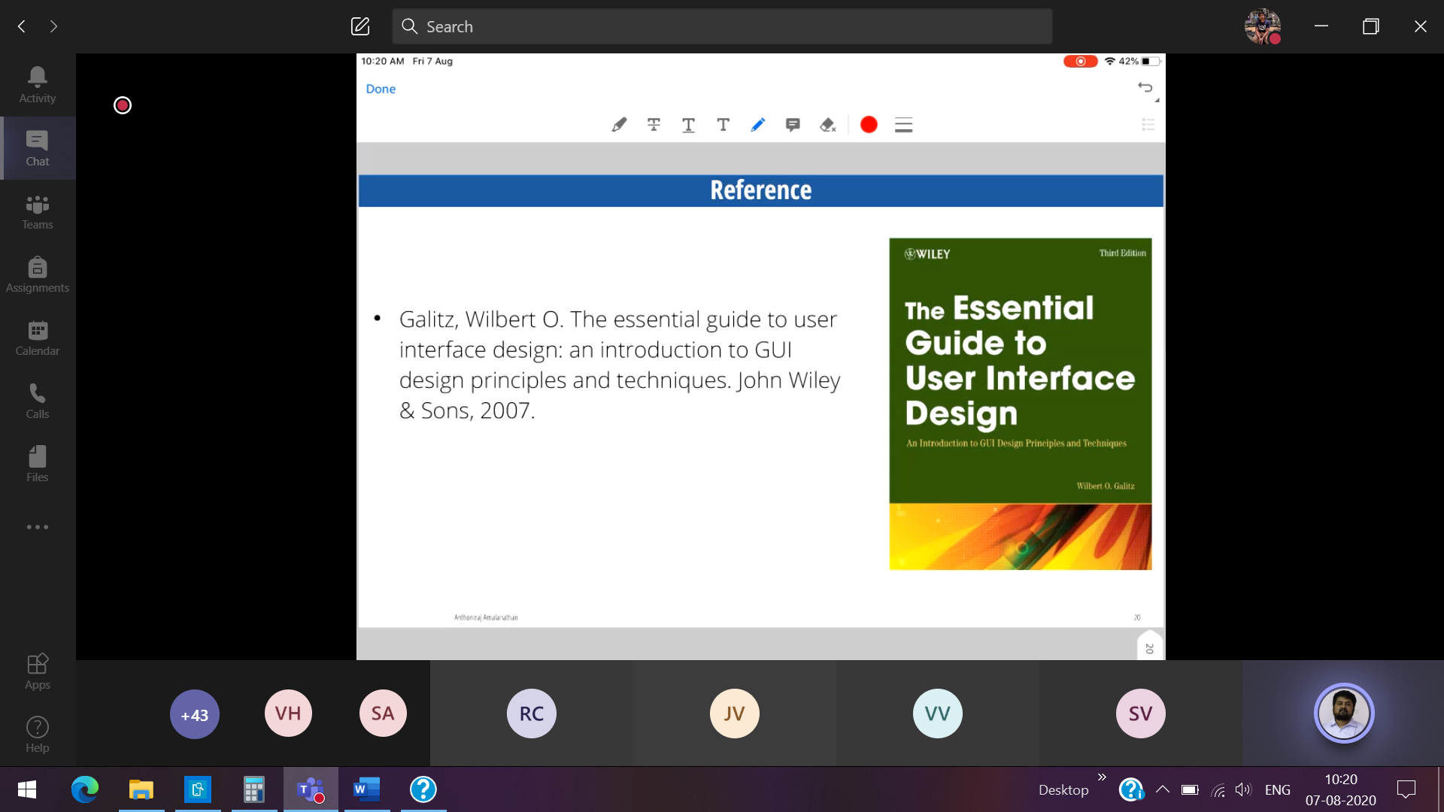

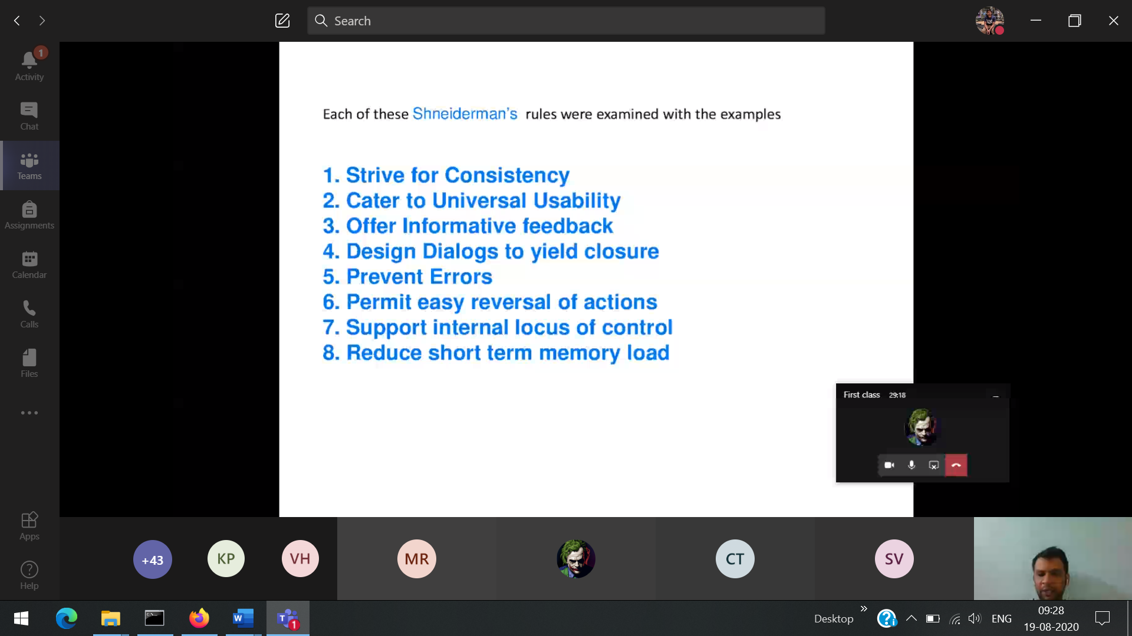

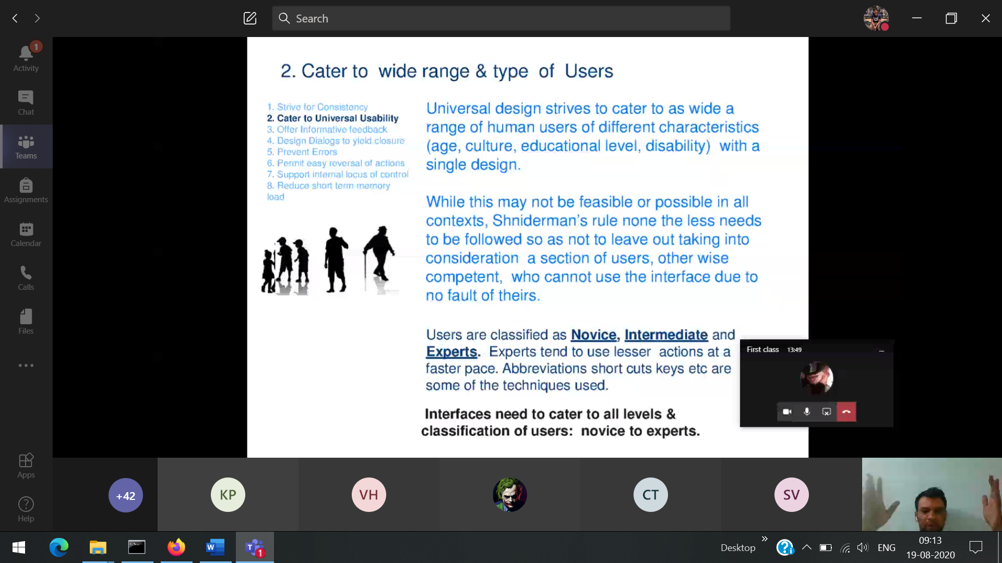

**10 Heuristic Principles**

1)Visibility of the system status ( always the user needs to be shown the status of the job doing).

If there is low internet connectivity, it should prompt that the email is loading

2)Match between the system and real world (Eg: recycle bin, ibooks app (looks like book shelf)

3) User Control and Freedom

4) Error prevention ( Prompt sending mail without subject, attachments)

5) Help user recognize, diagonize are recover from errors (delete prompt)

6) Maintaining the consistency

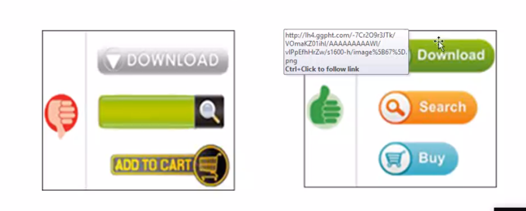

1st page 2nd page

7) Recognition rather than recall

8) Flexibility and efficient use

9) Aesthetic and minimalist design

10) Help and Documentations

Sign in Page

User name 🡪 [ Highlights us what to enter in the user name ]

Password 🡪 [ Highlights the constraints of the passwords] 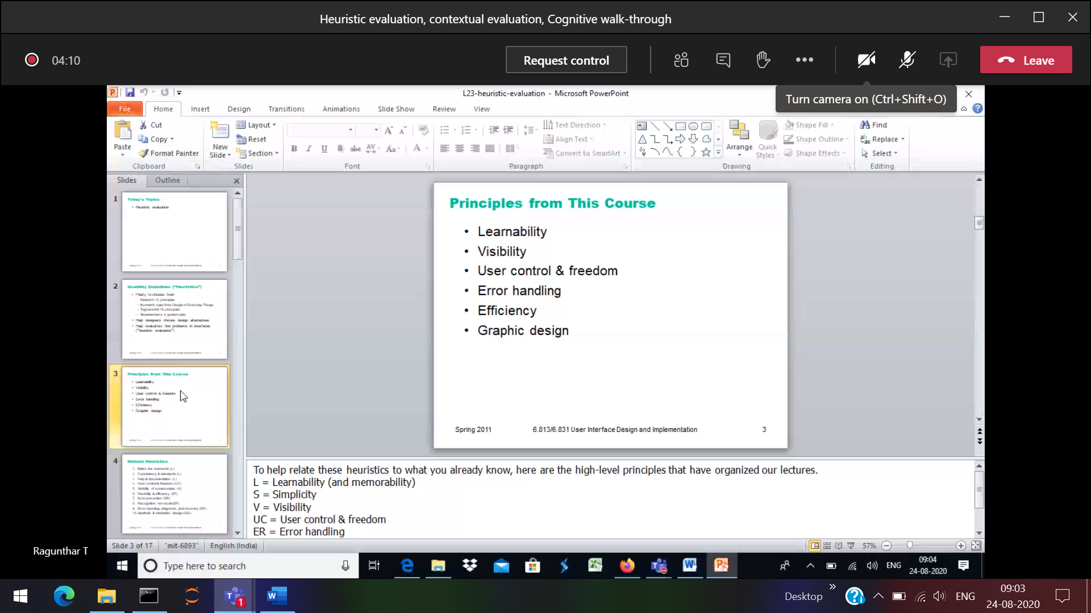

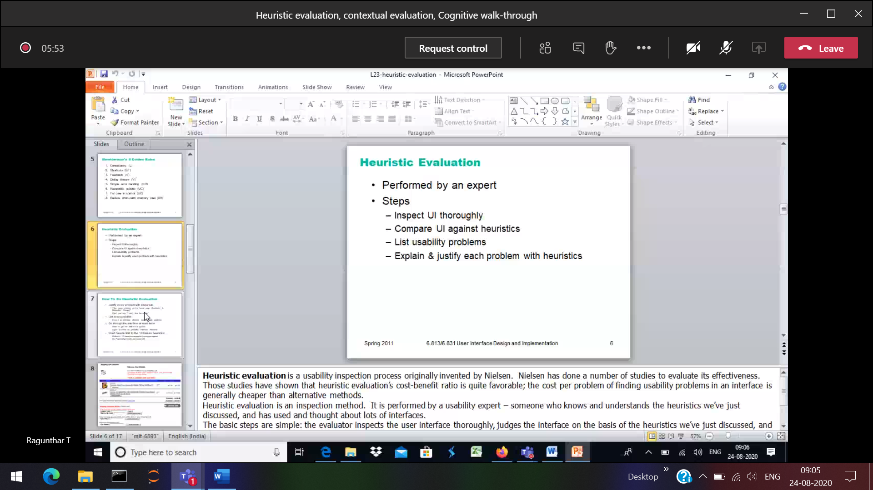

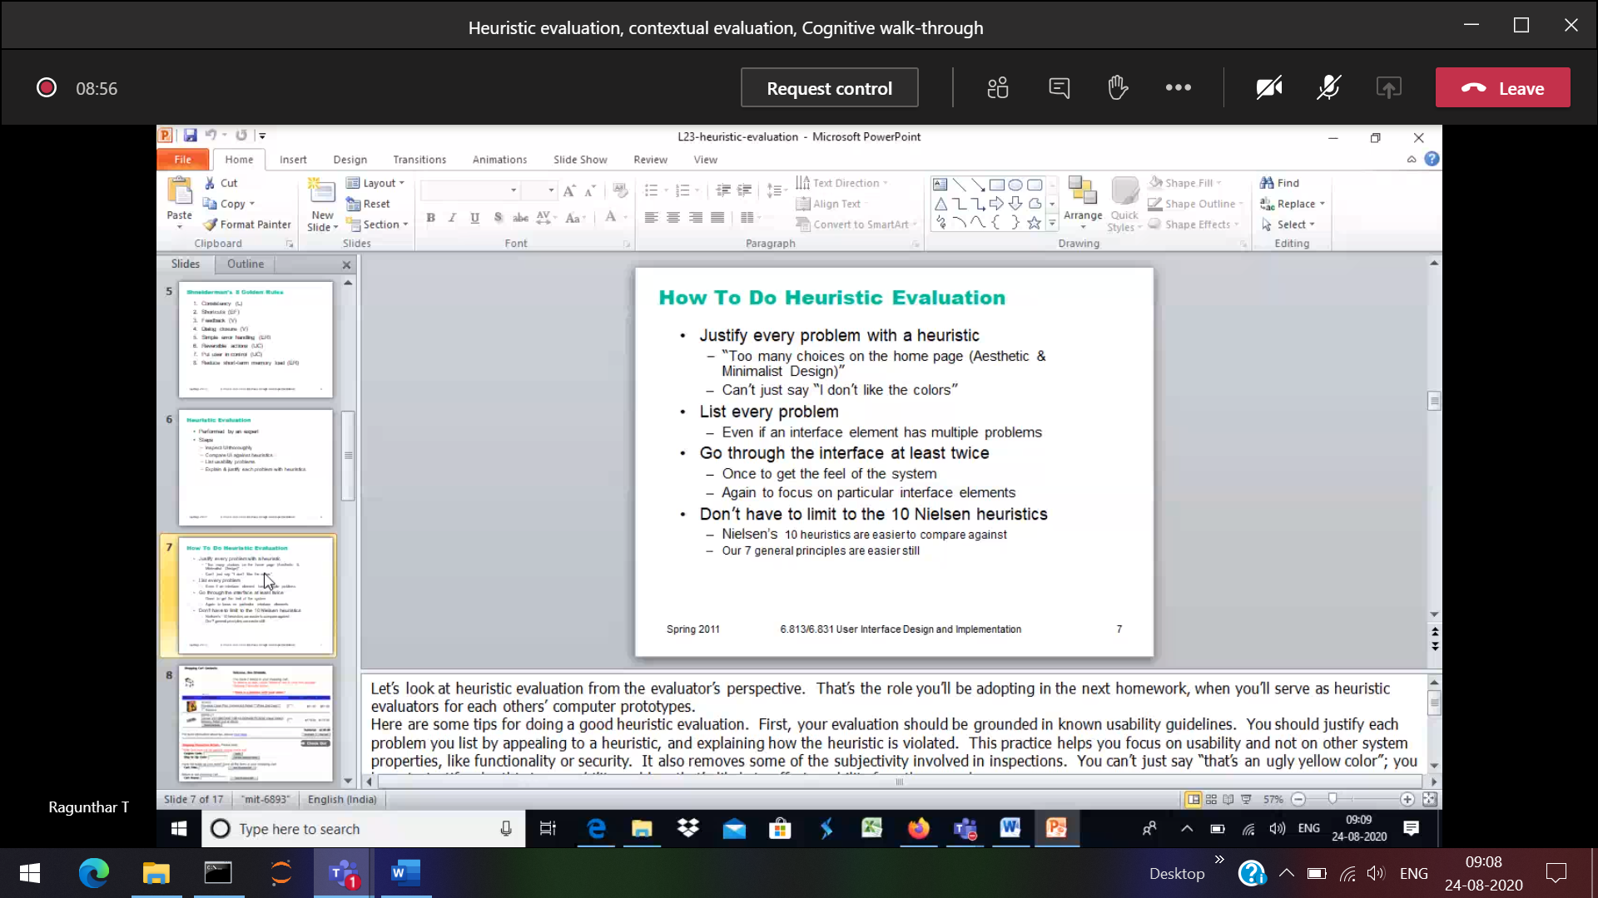

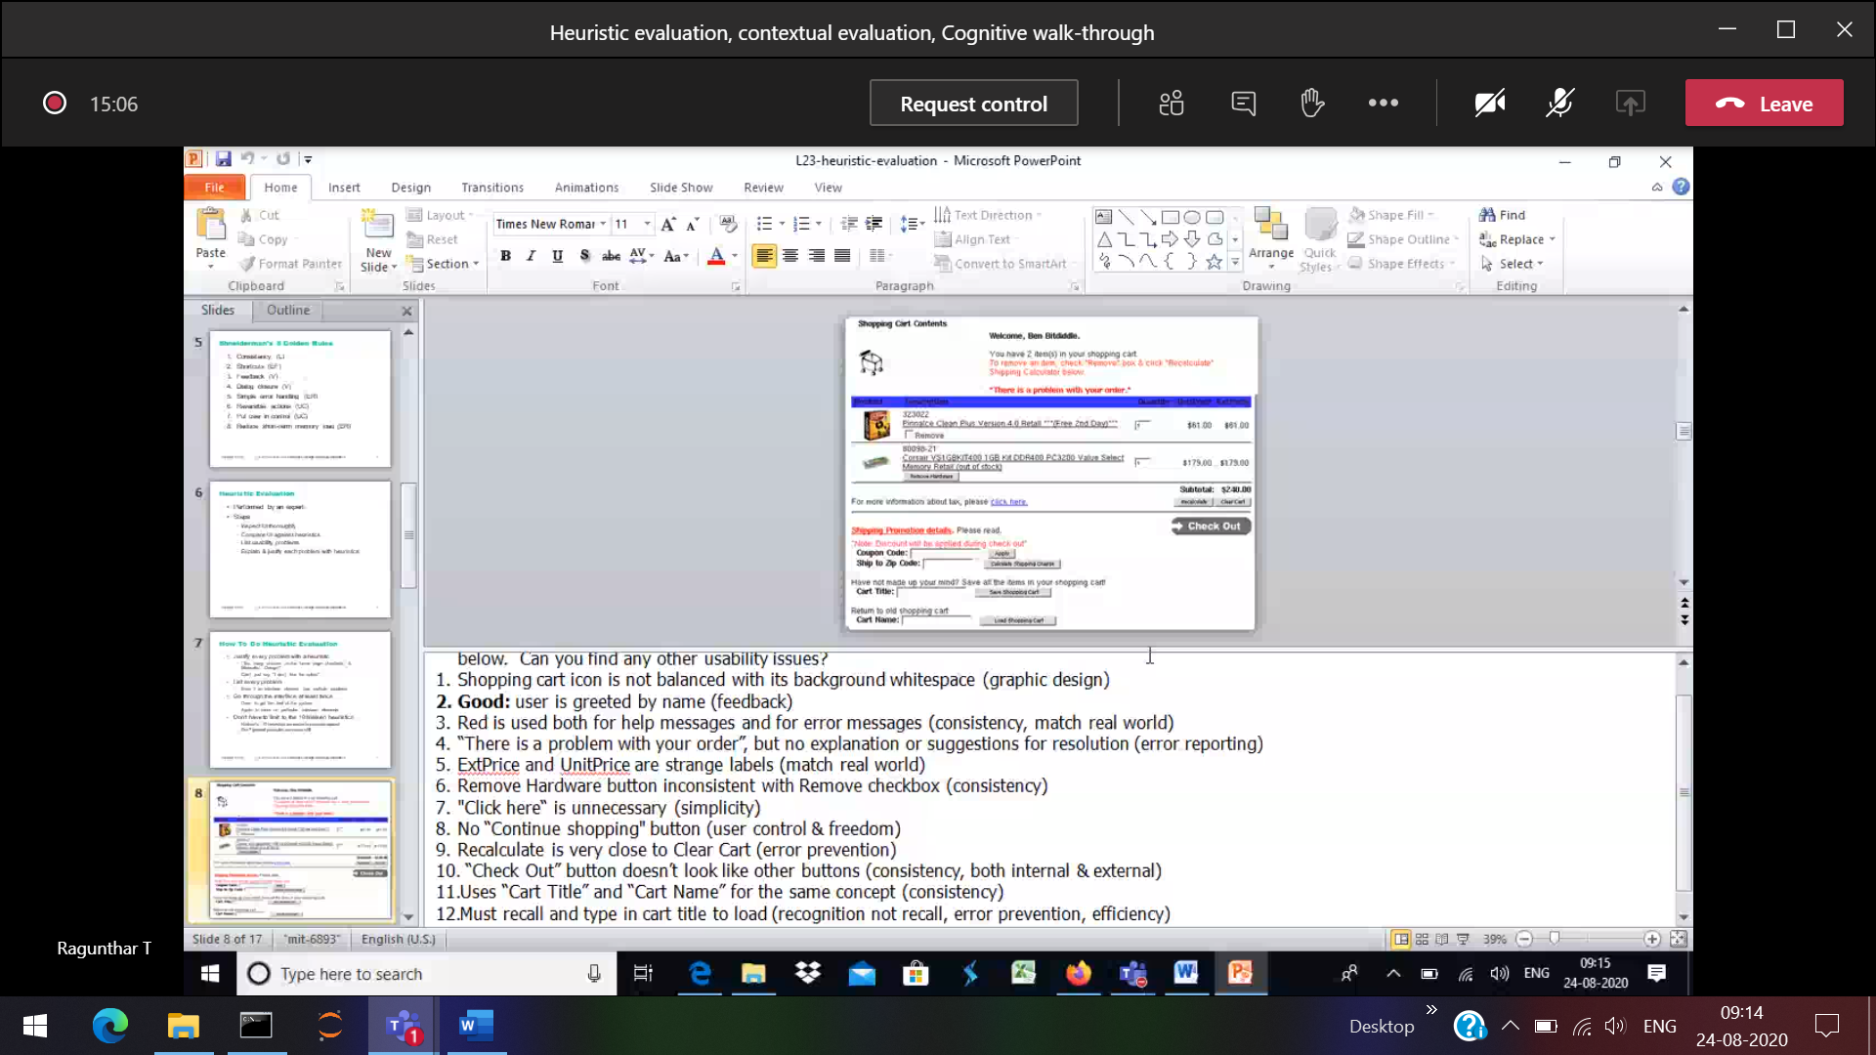

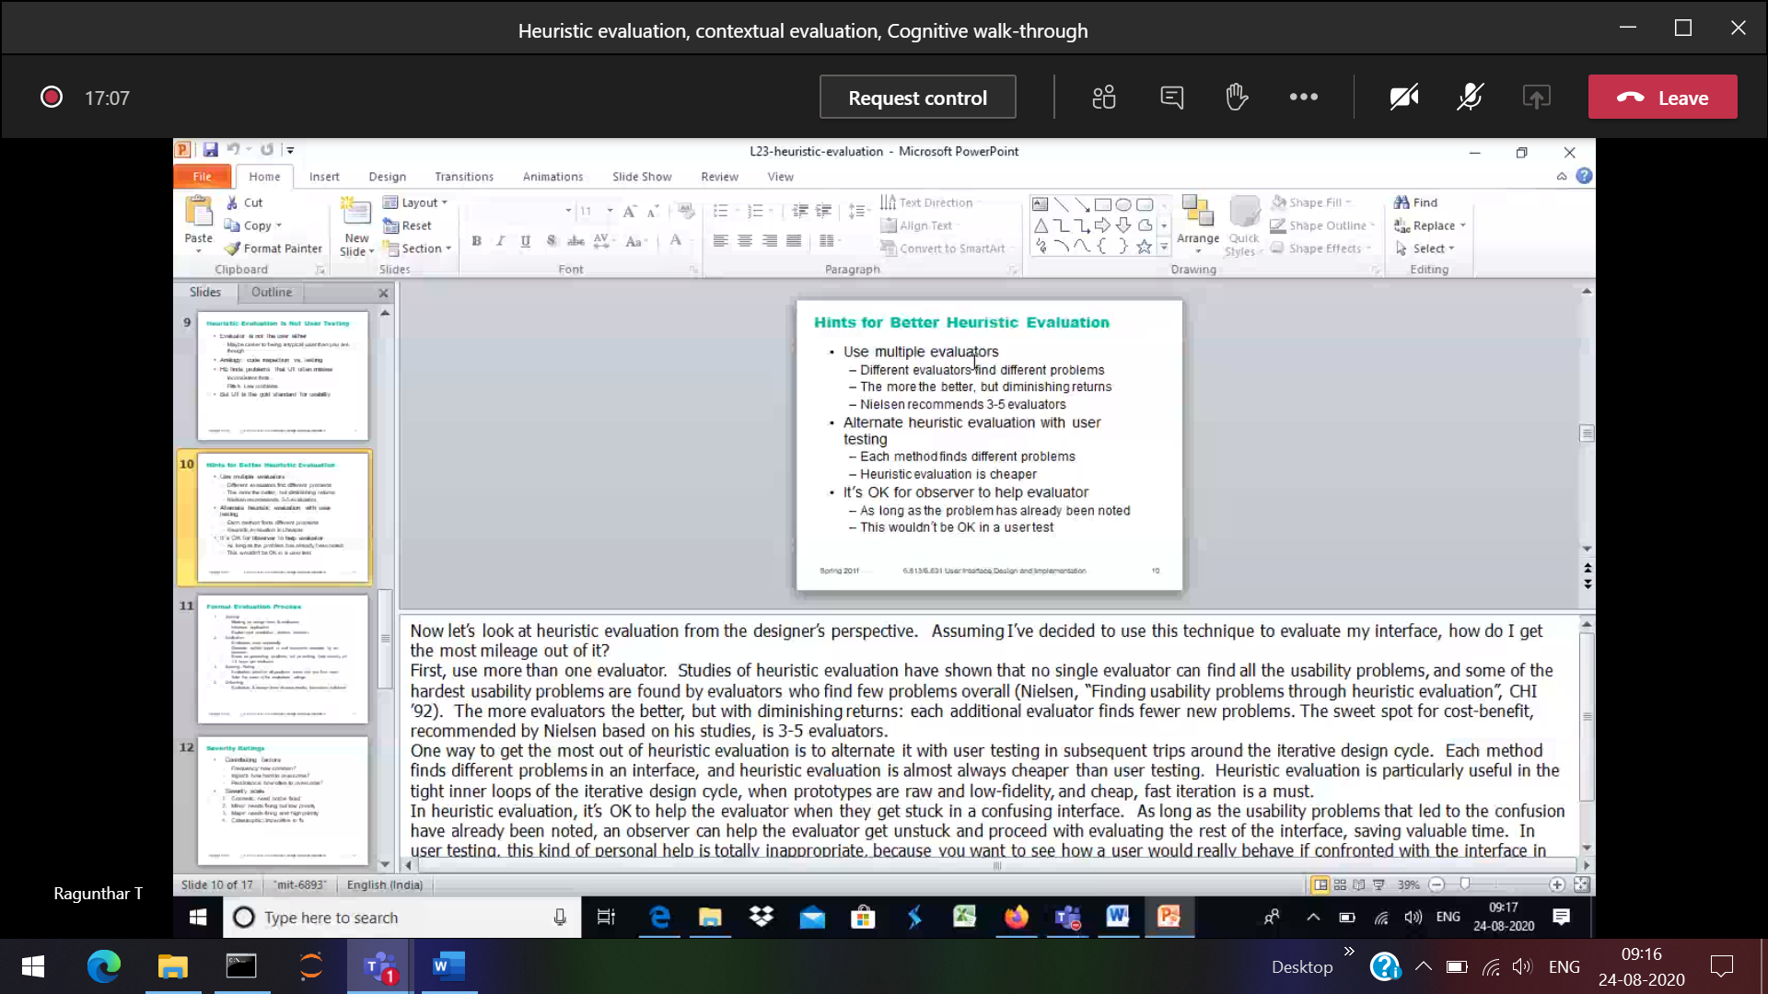

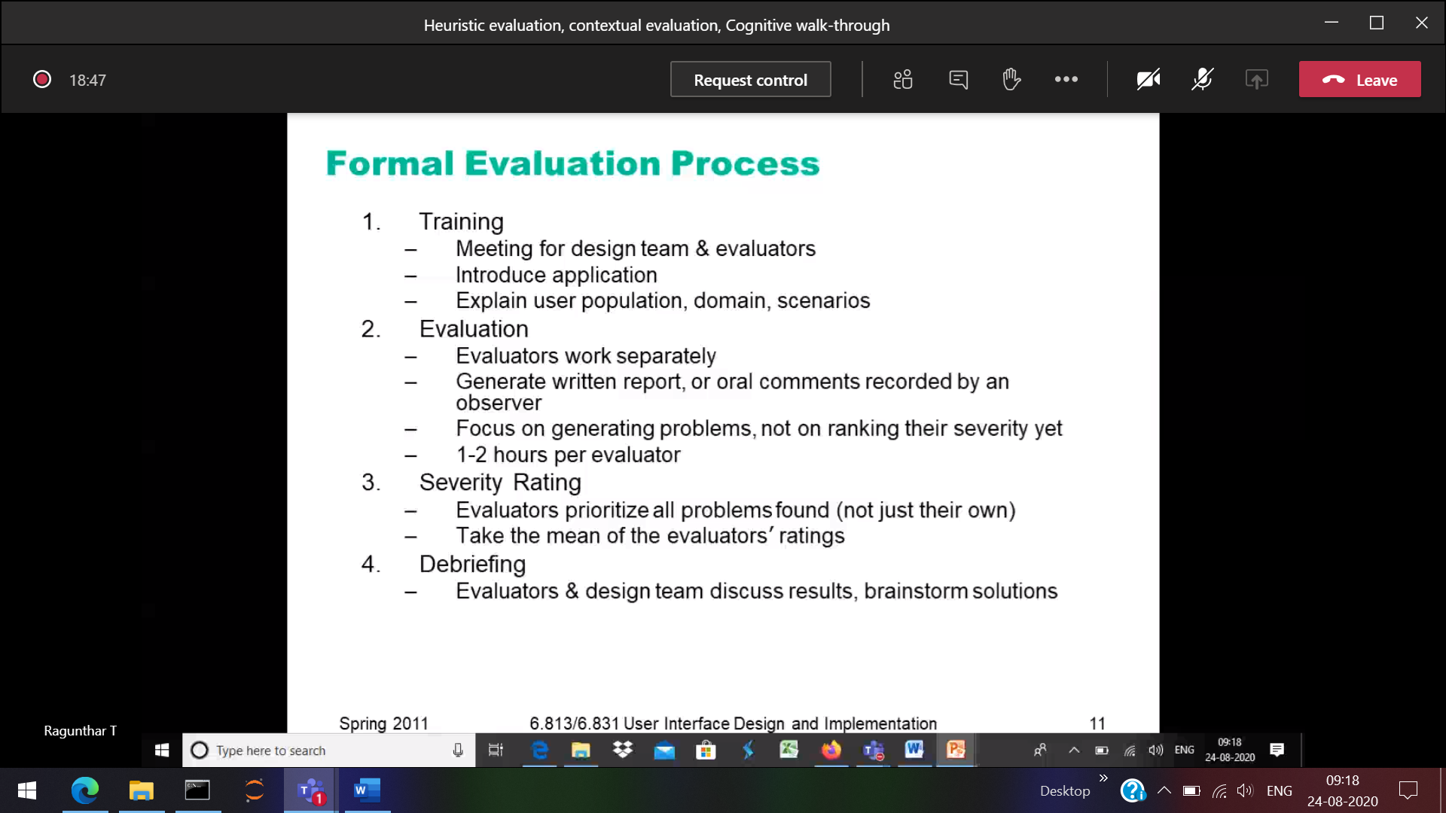

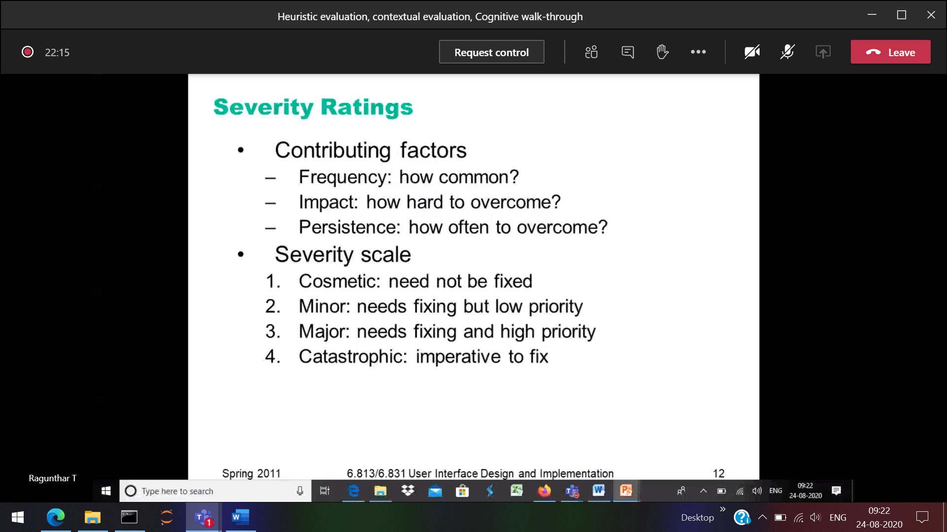

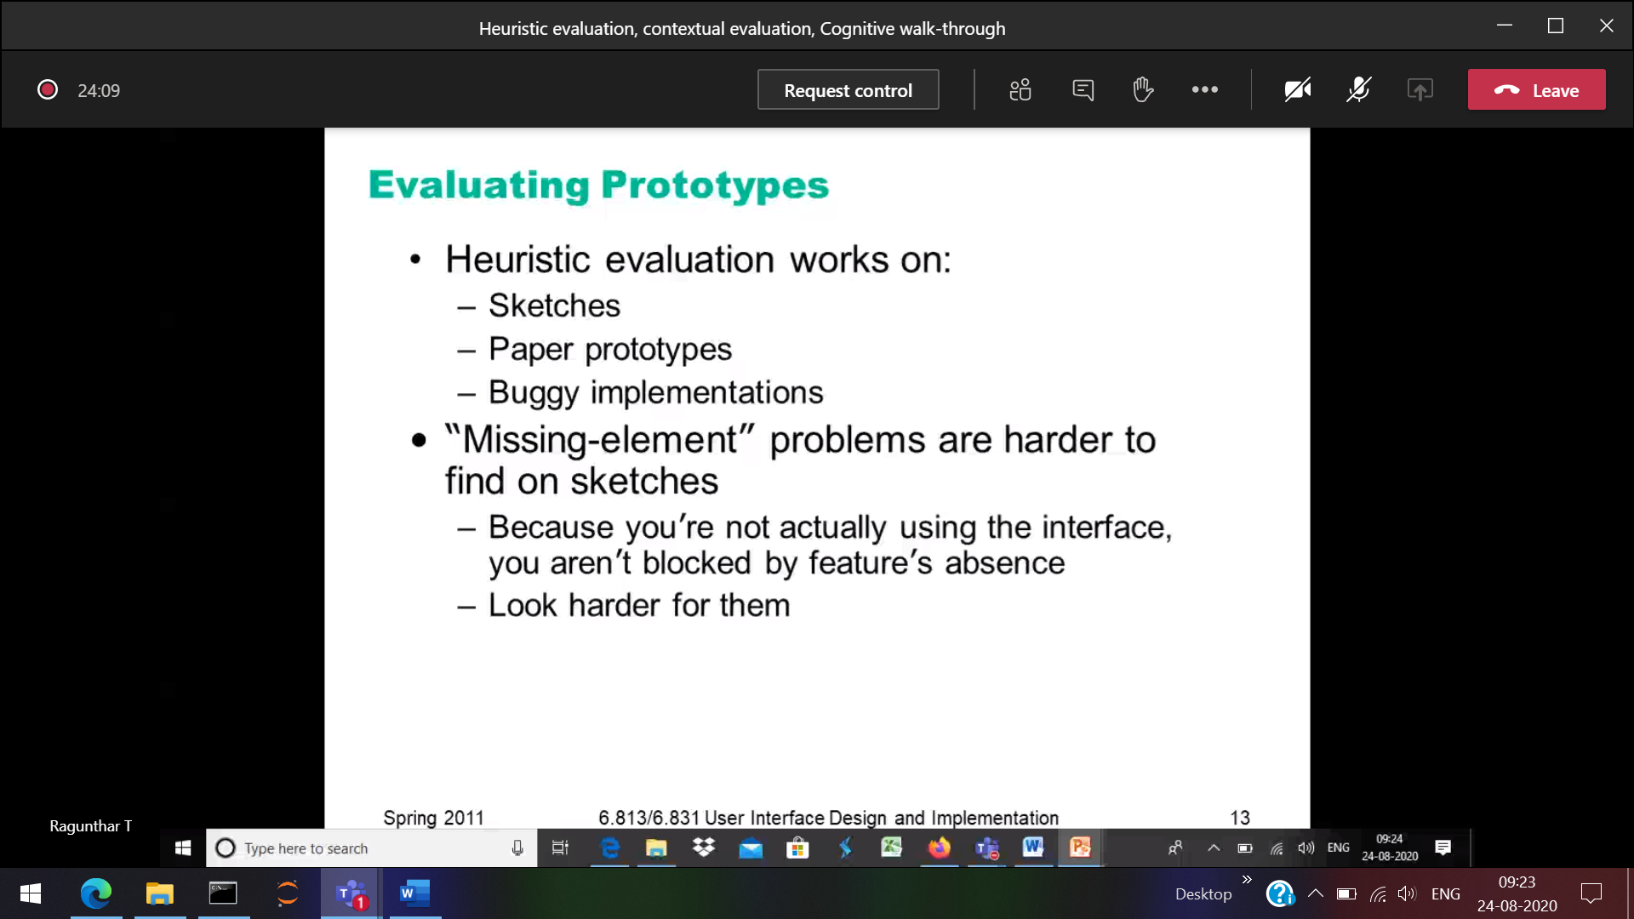

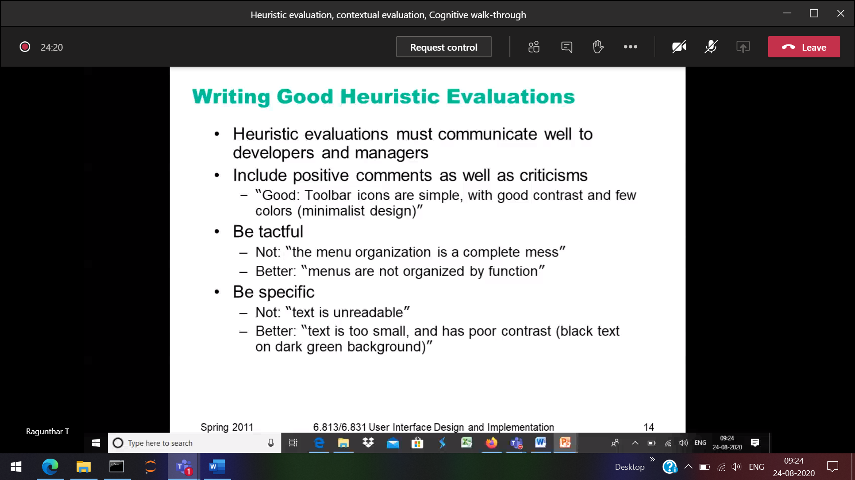

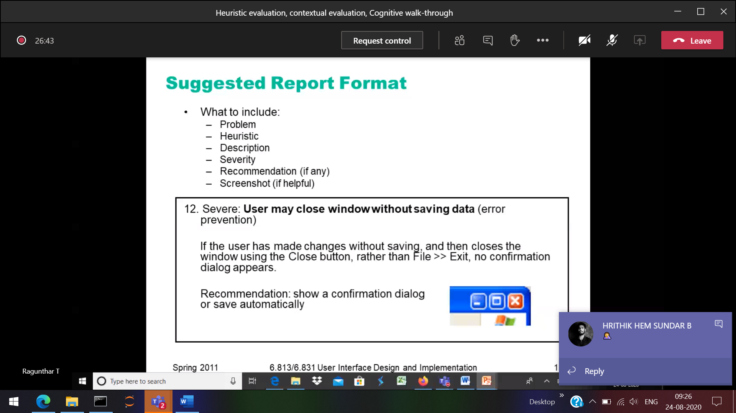

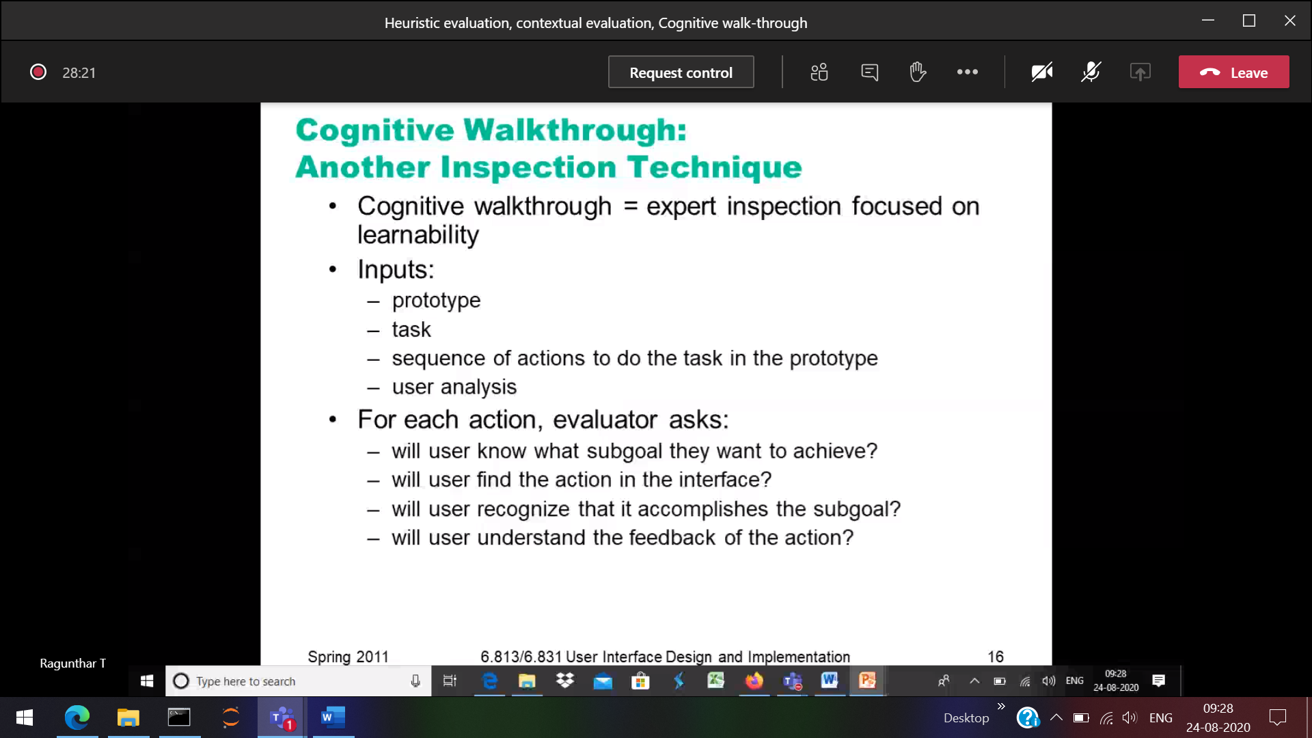

Cognitive Walkthrough

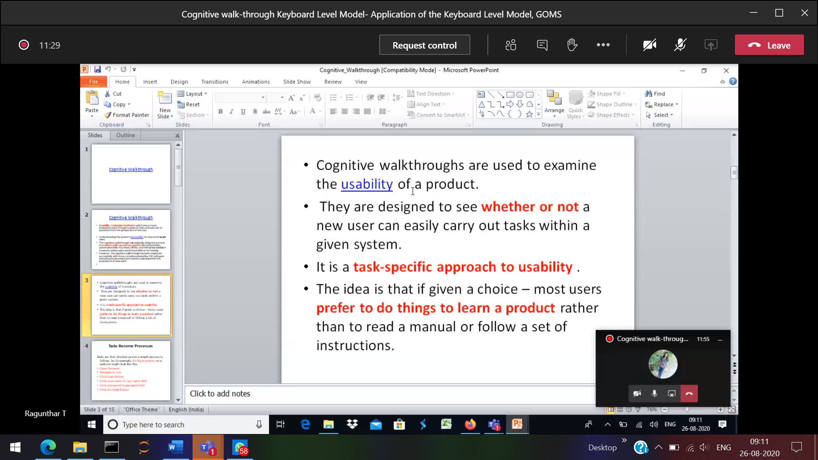

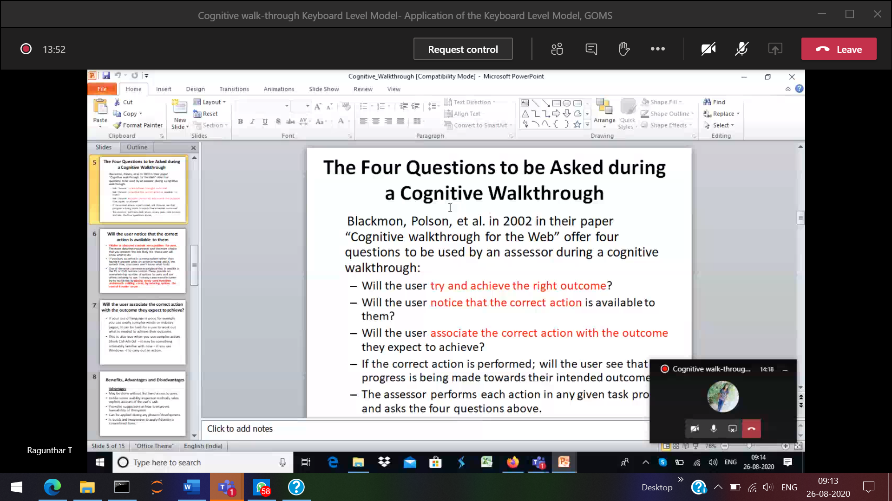

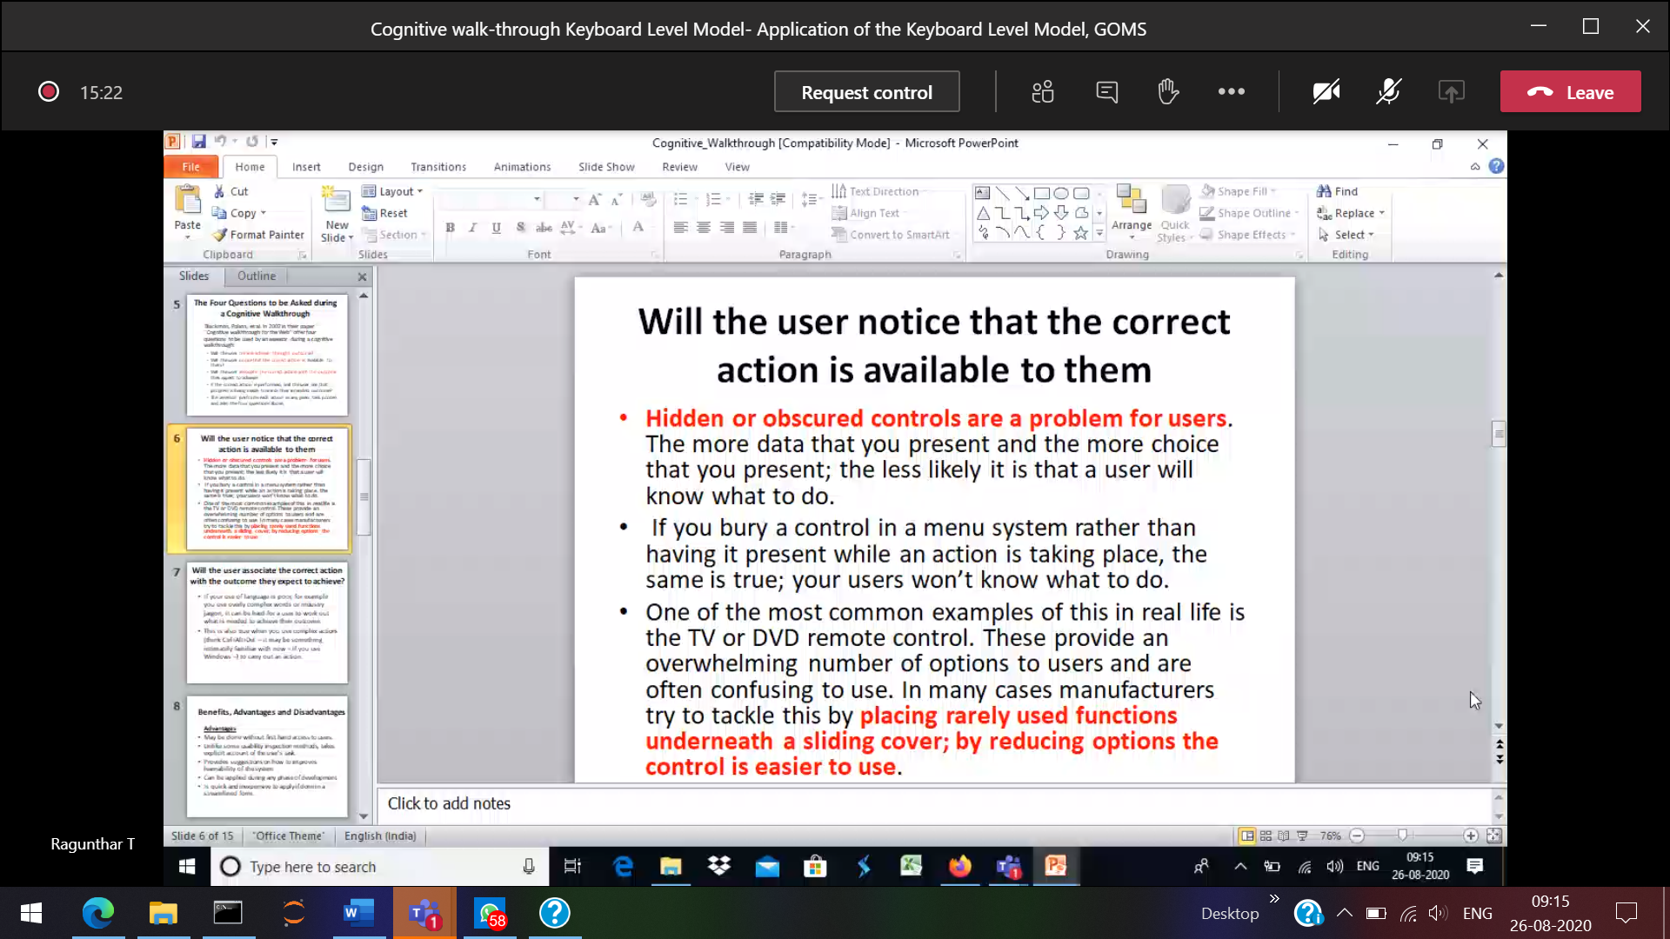

Without login button, we cannot be able to enter into.  
Showing the unwanted menus and buttons instead of login 🡪 then the user will be irritated

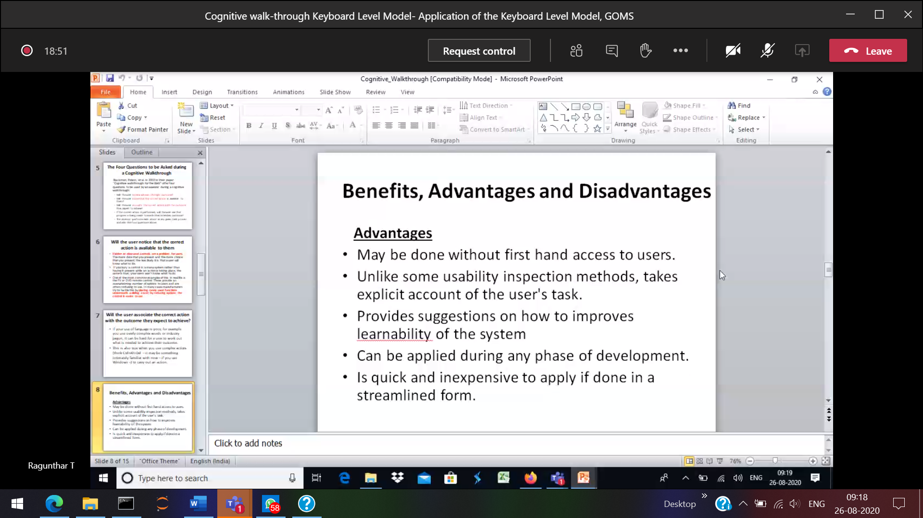

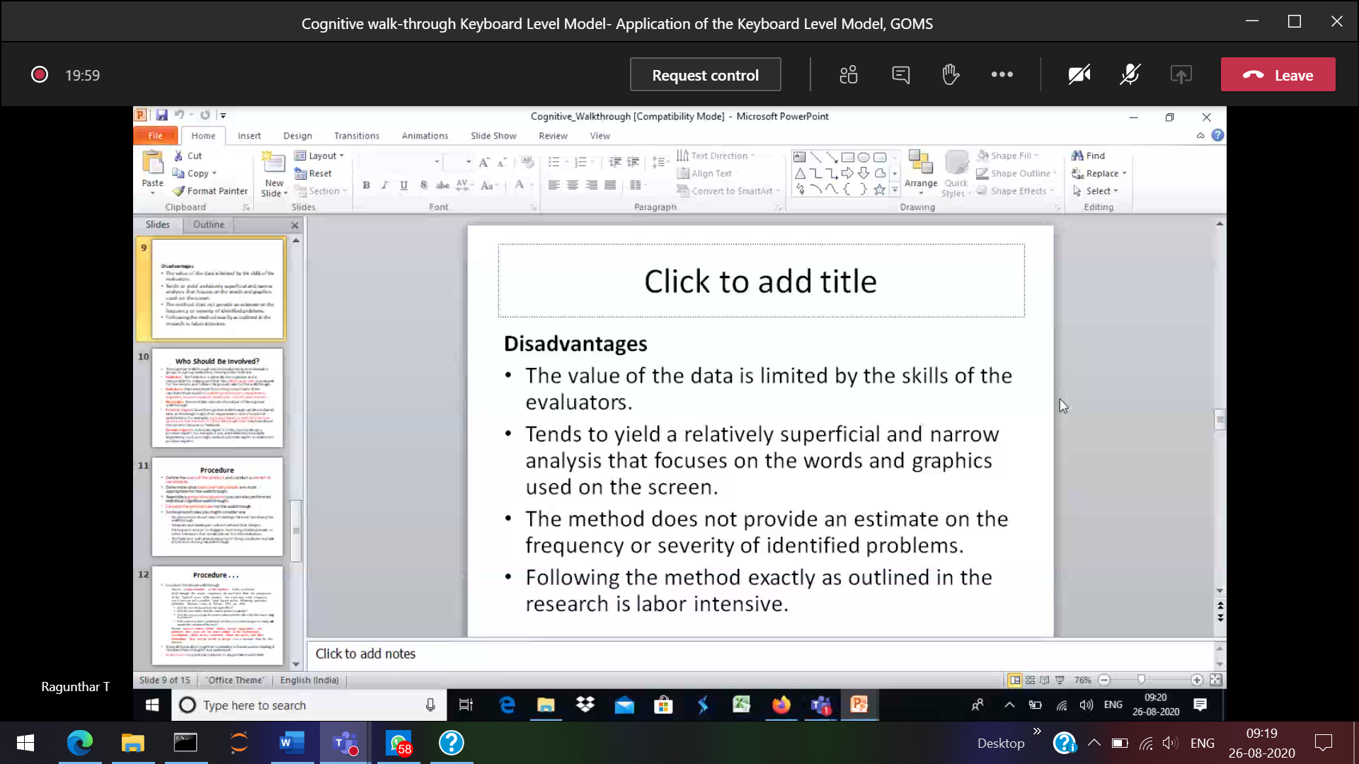

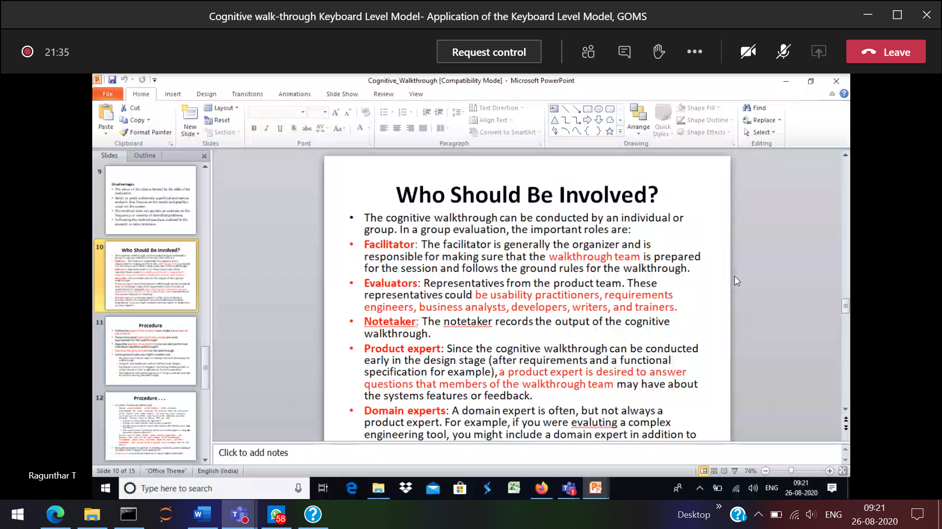

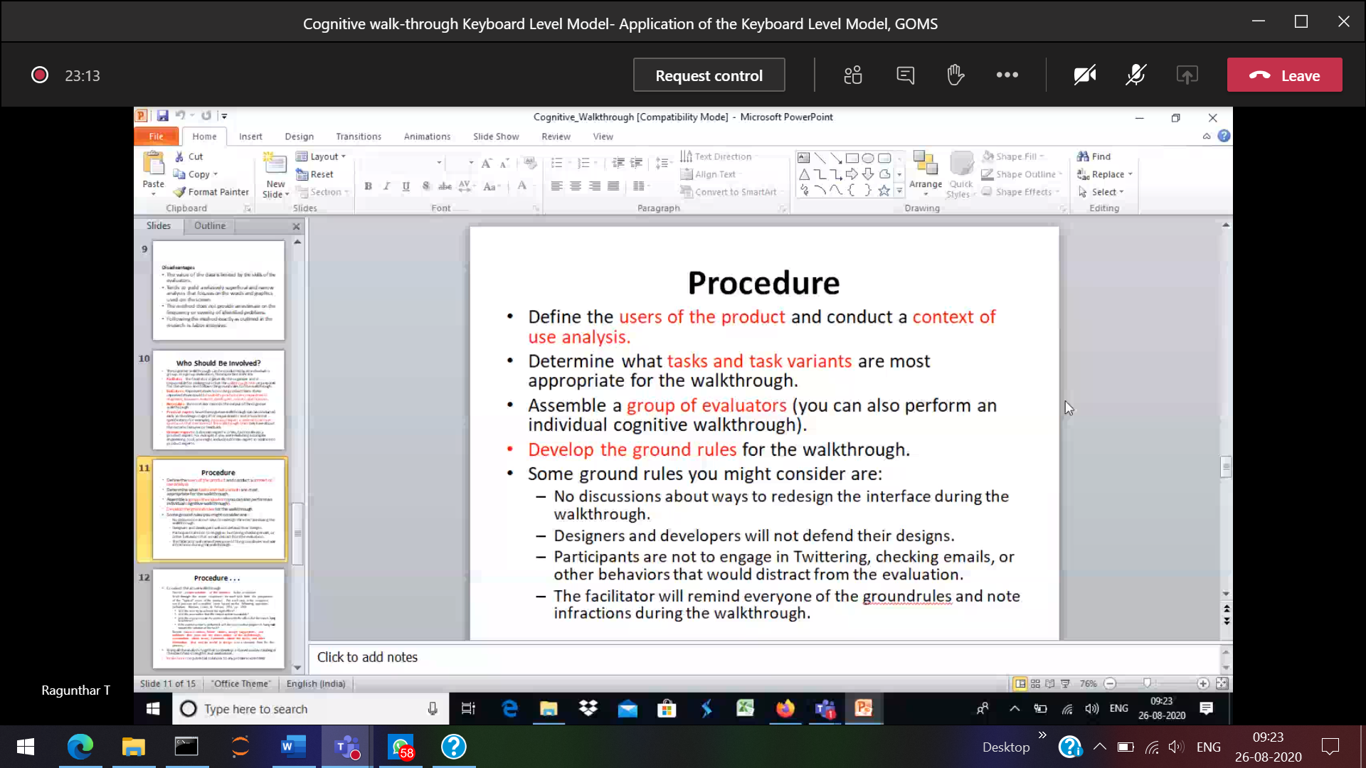

GOMS Model

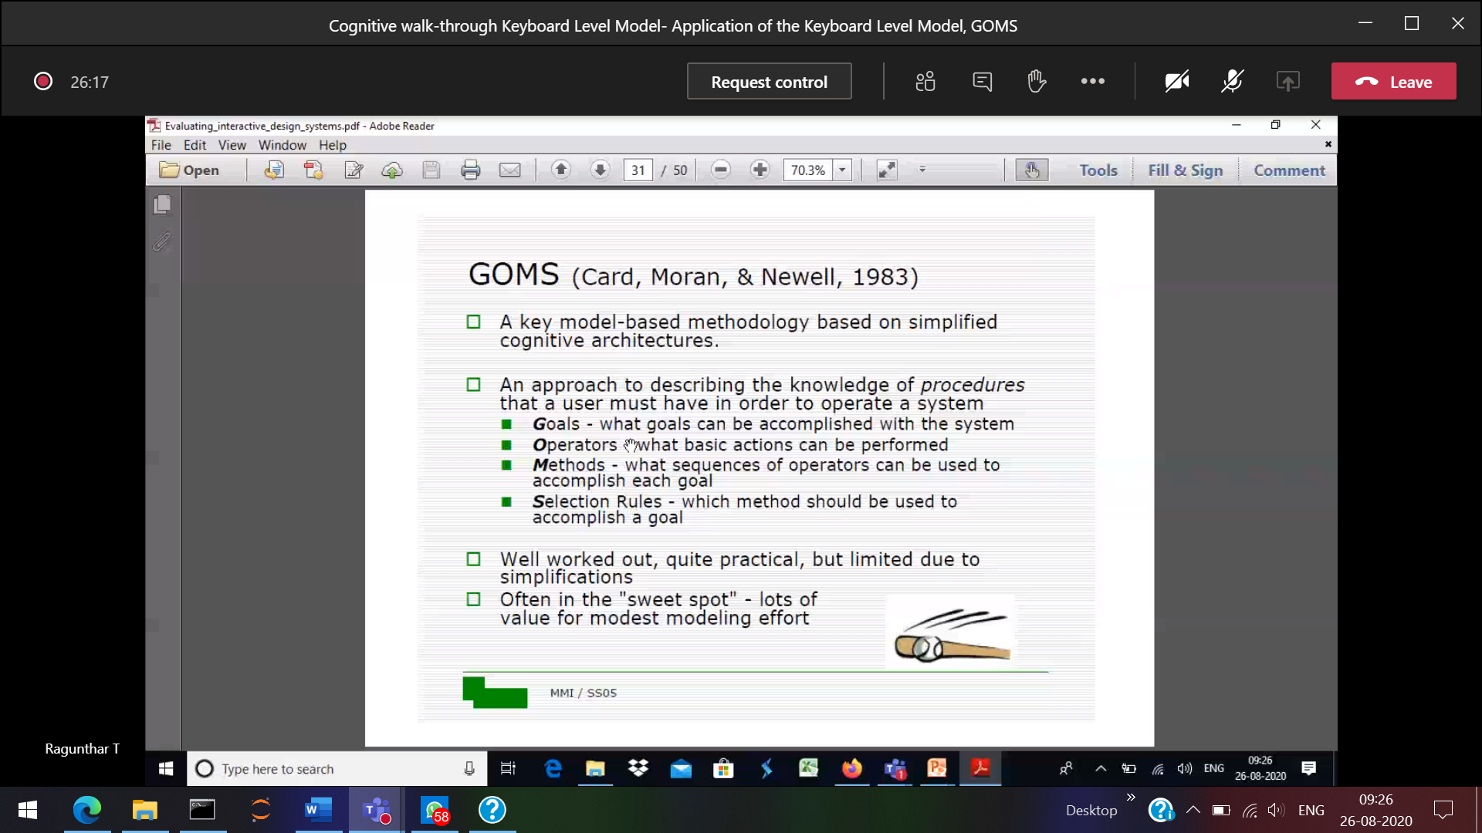

Goal 🡪 deleting a file ,

Selection model 🡪 A file can be deleted by using Keyboard and mouse

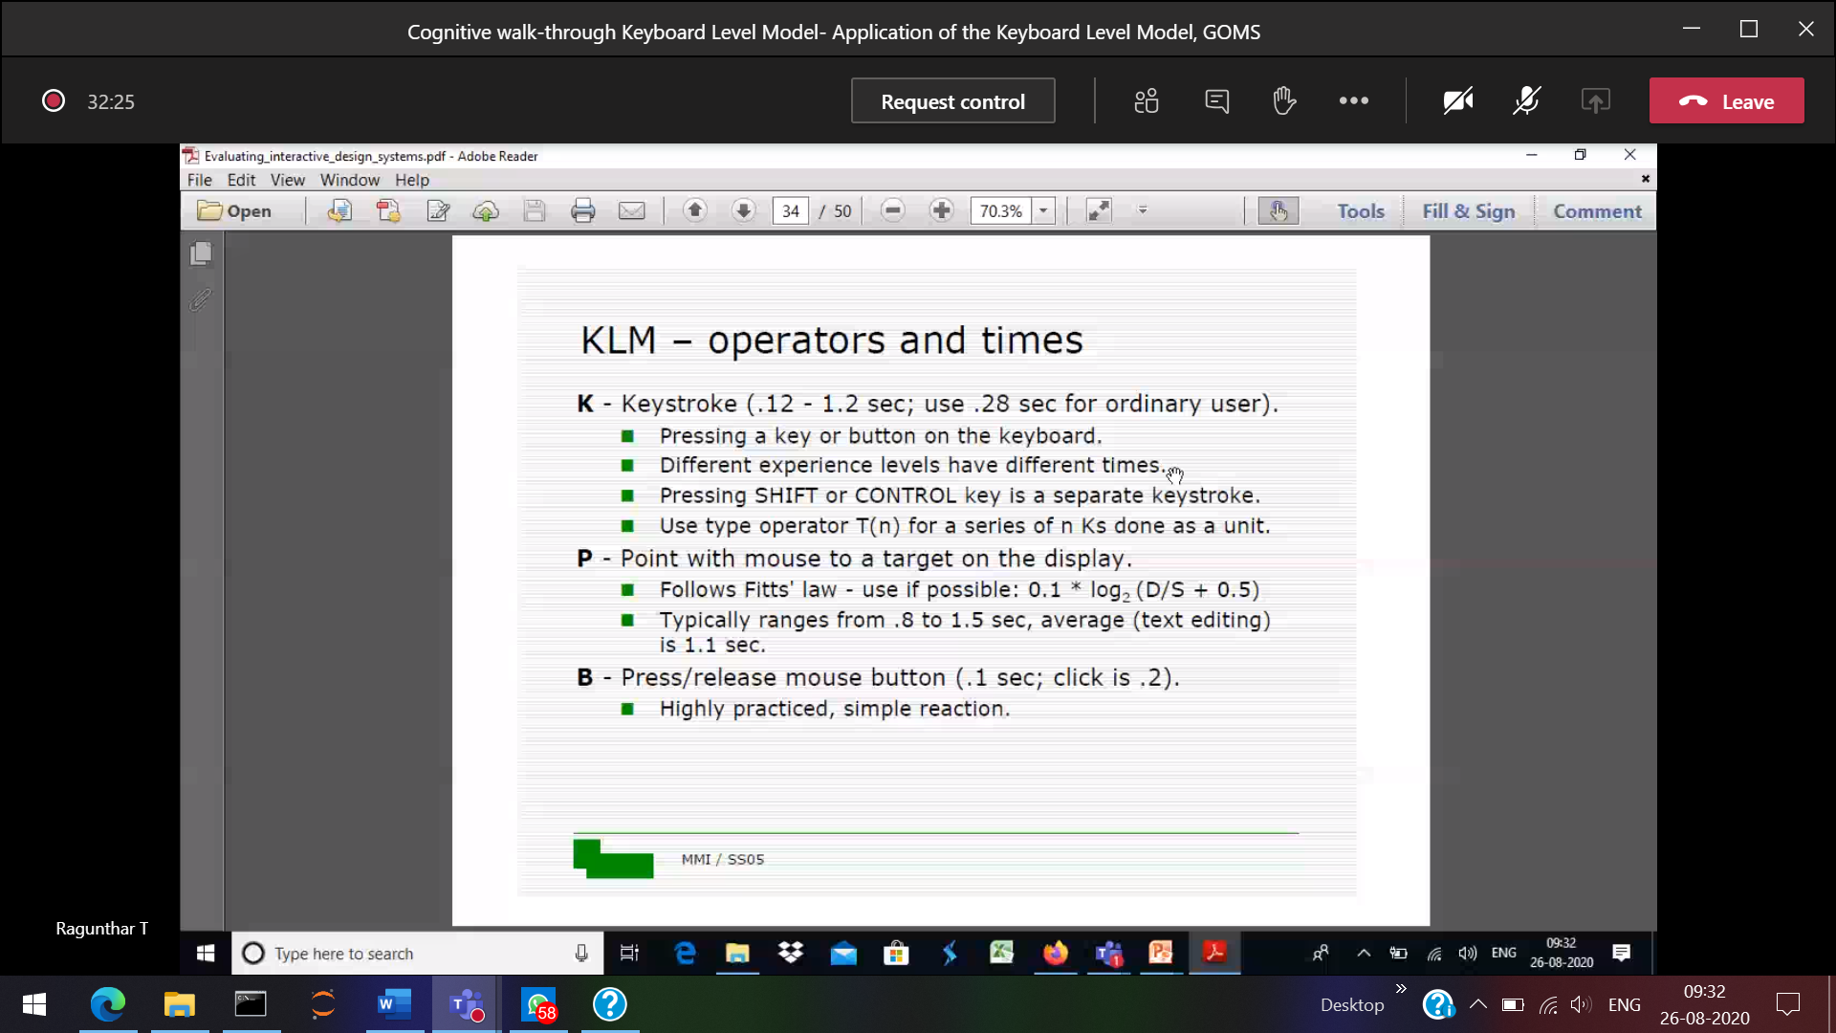

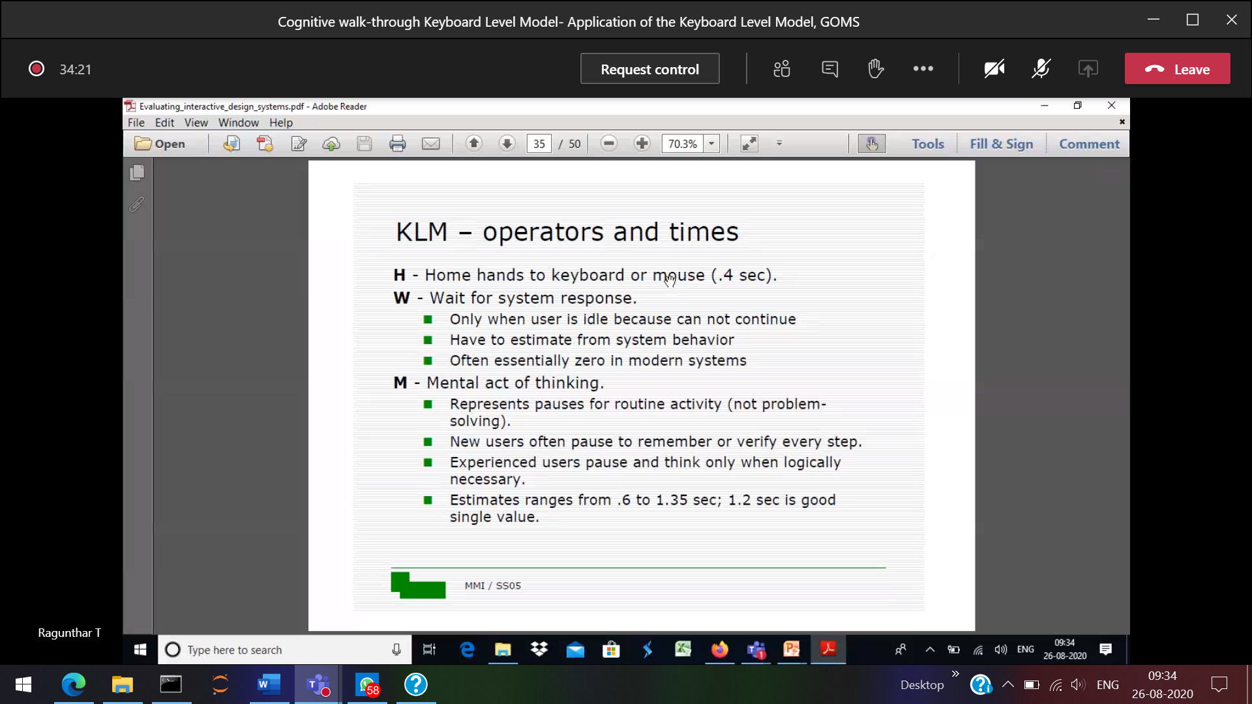

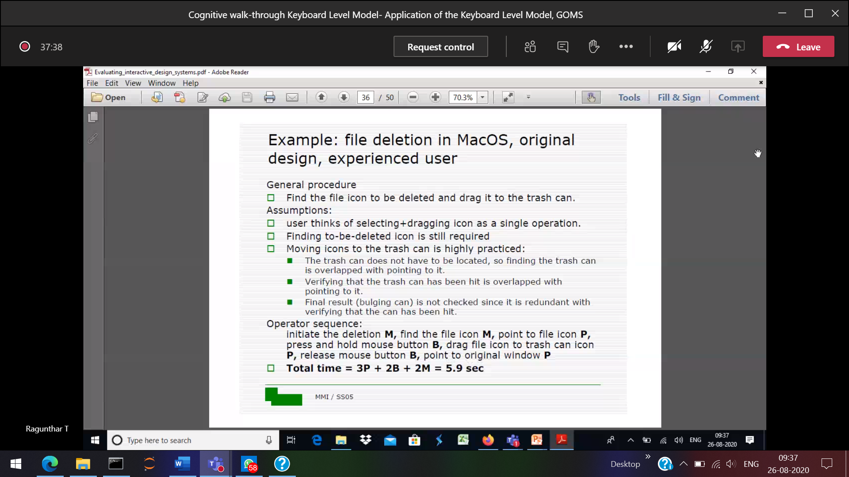

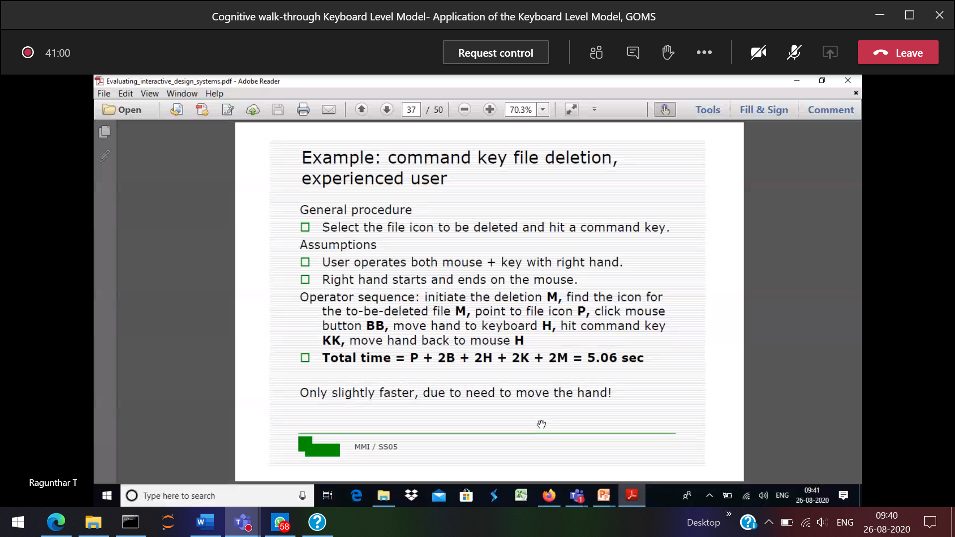

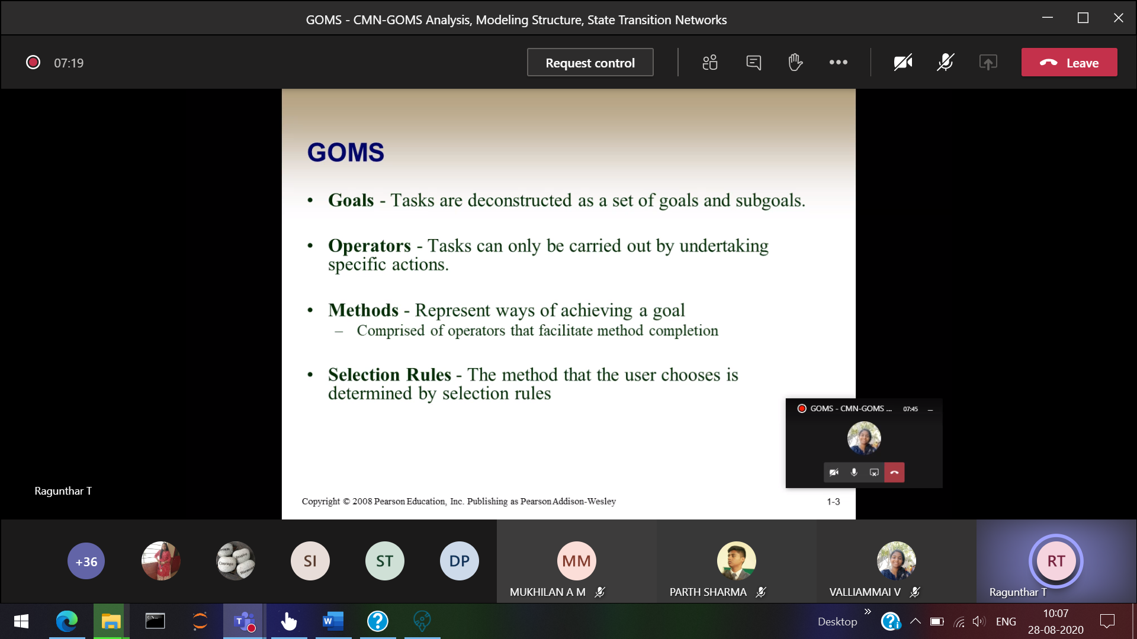

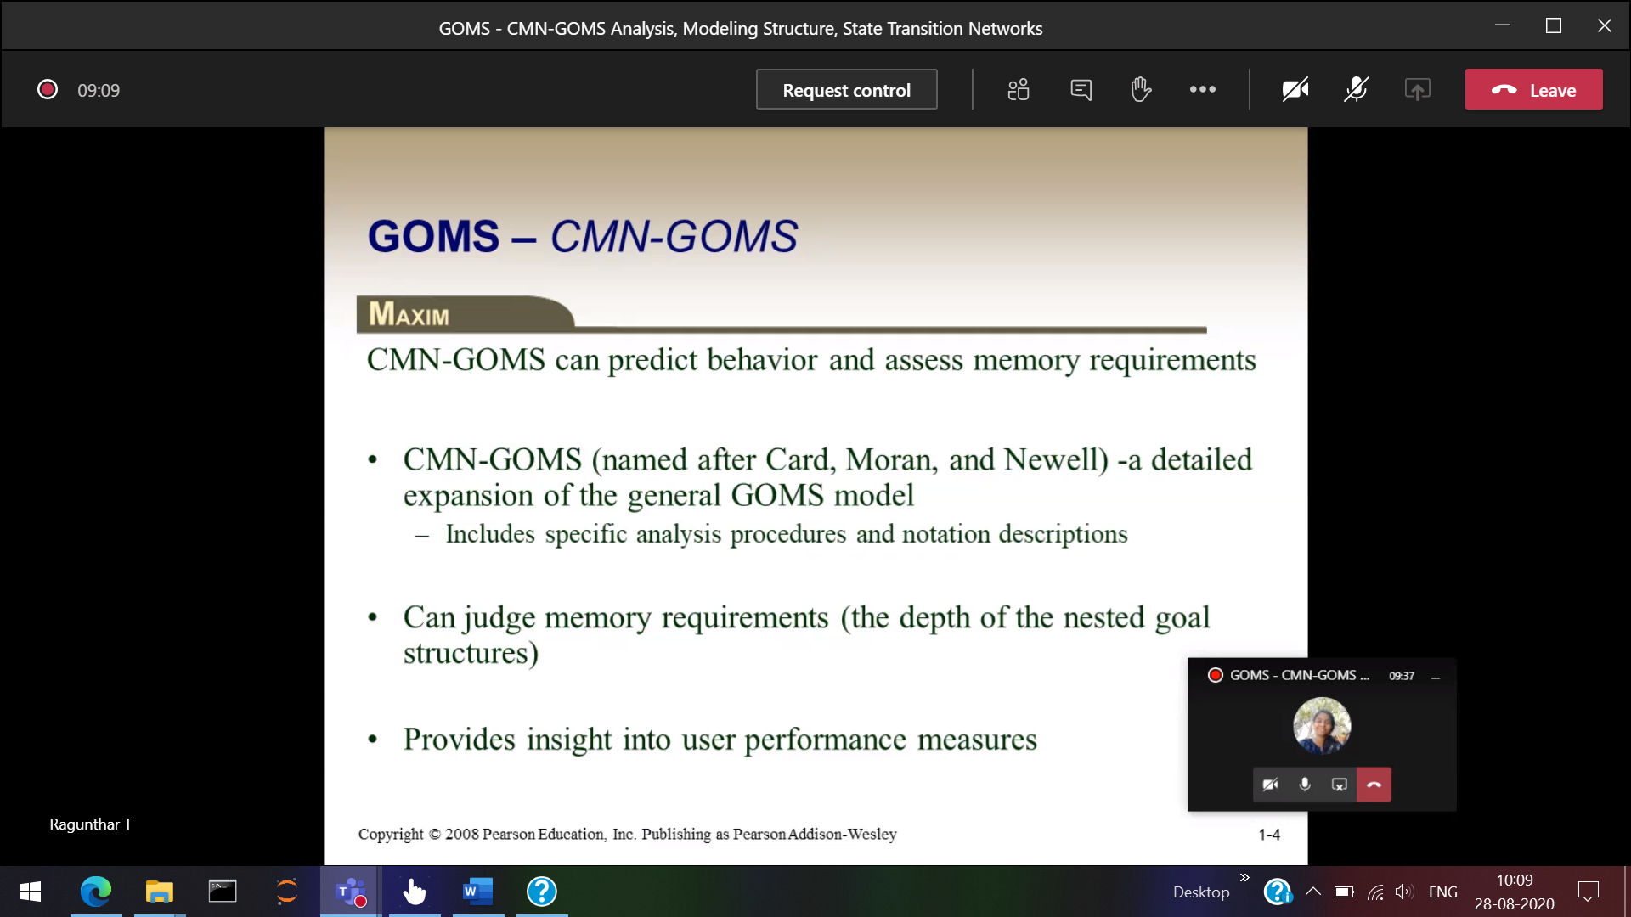

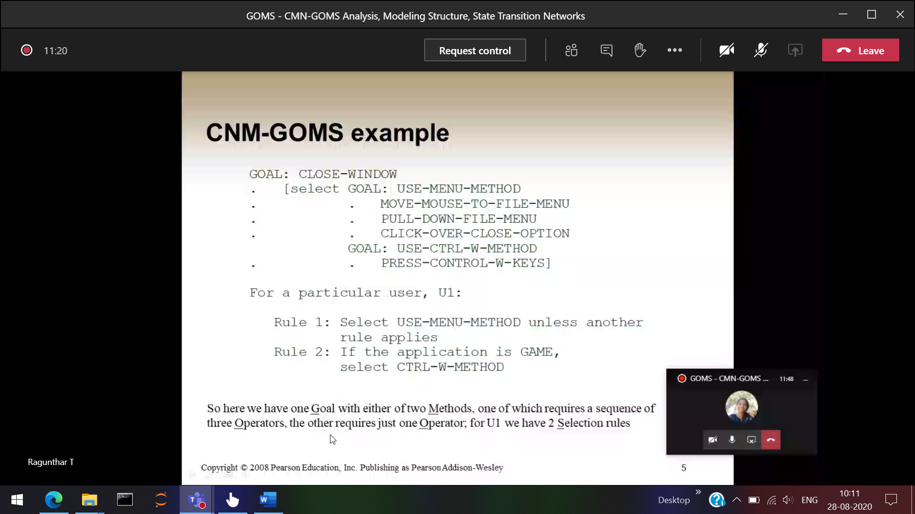

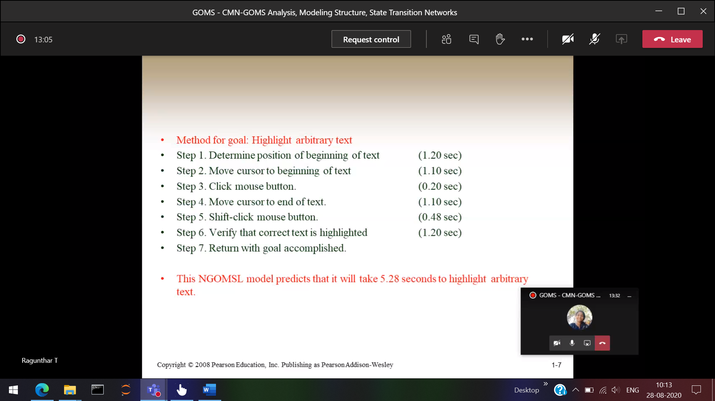

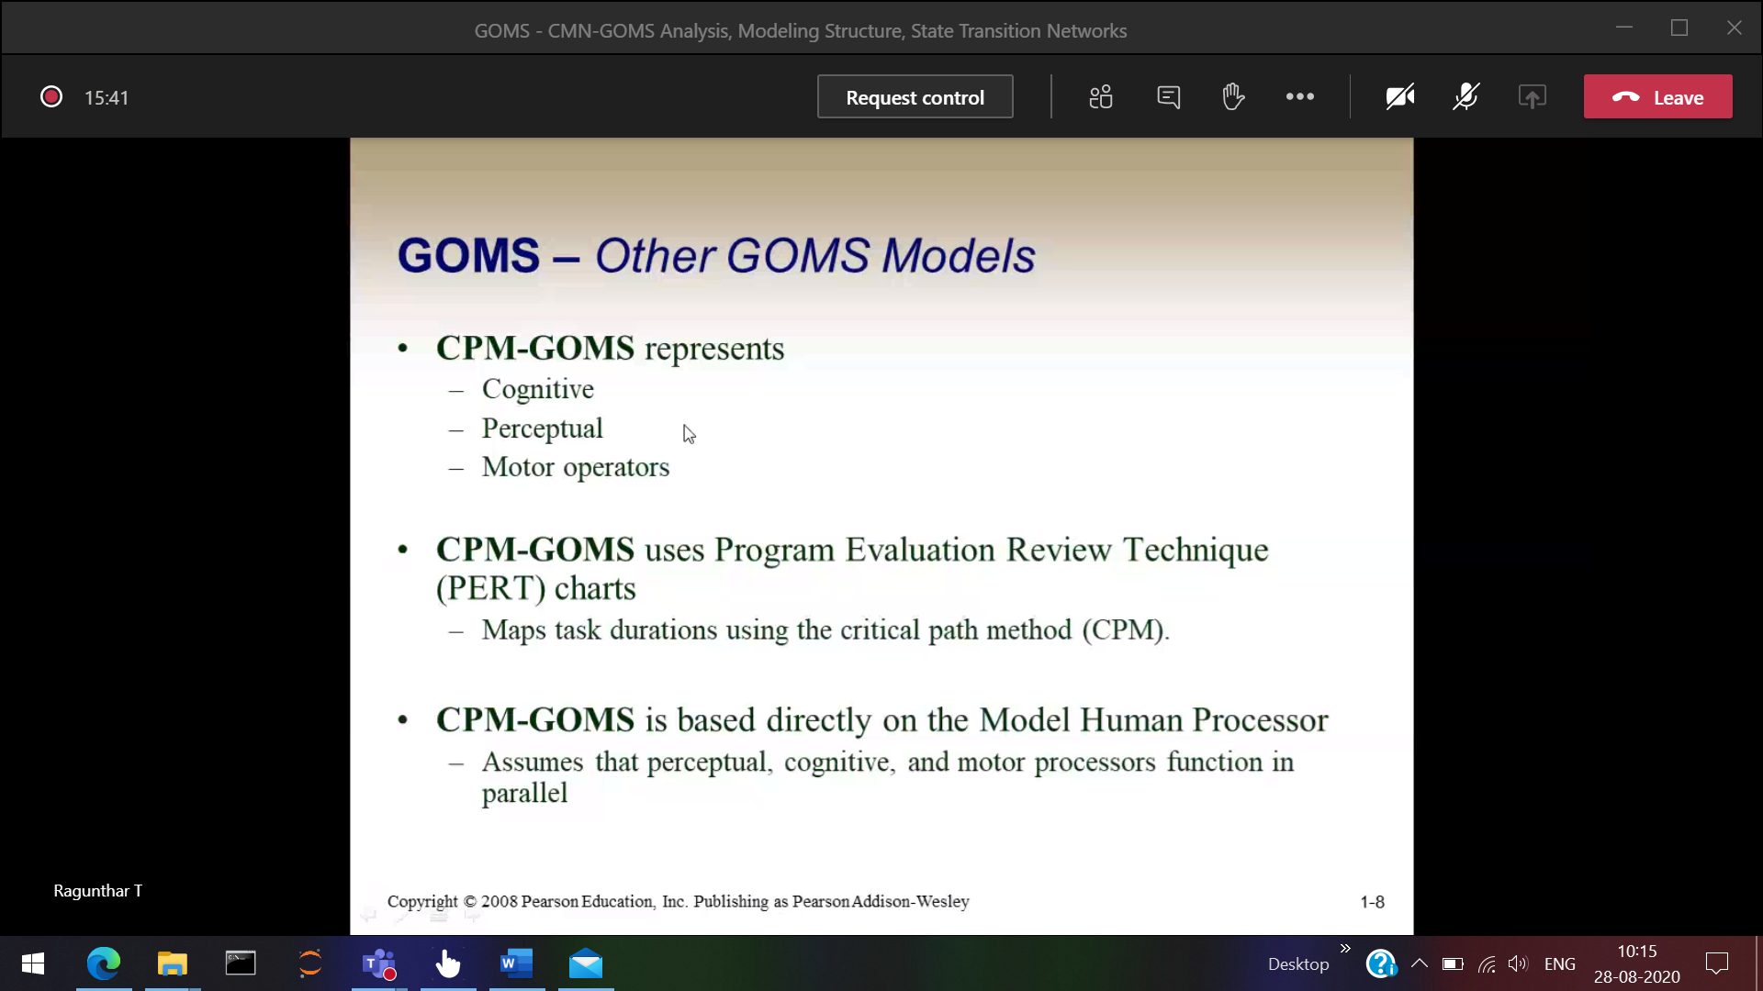

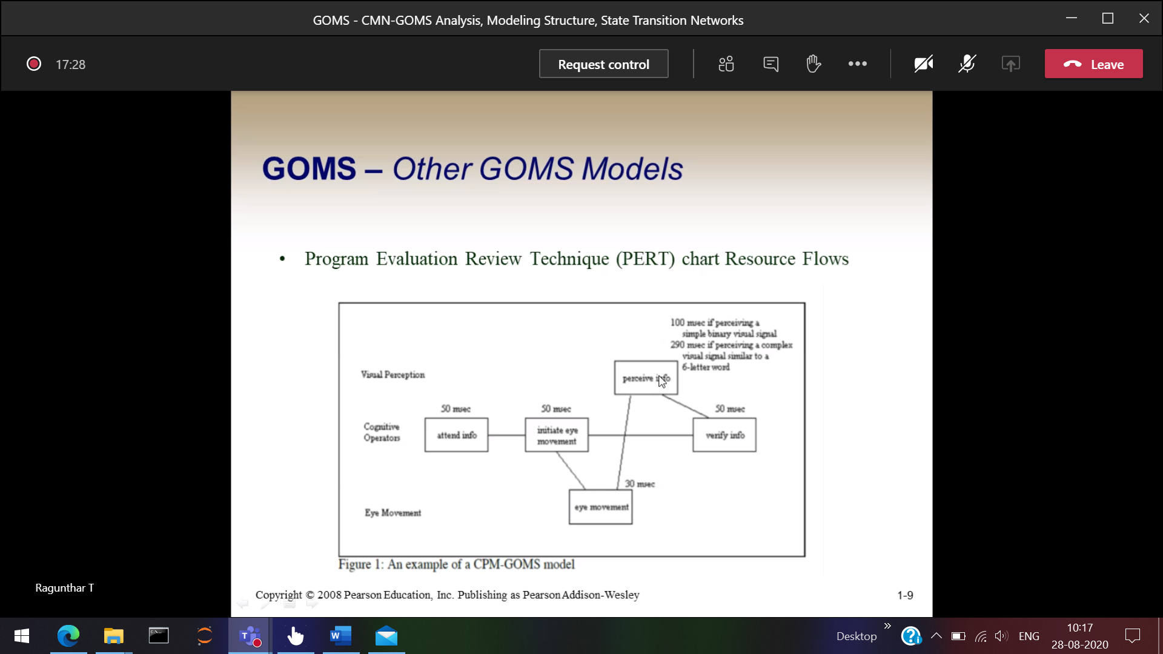

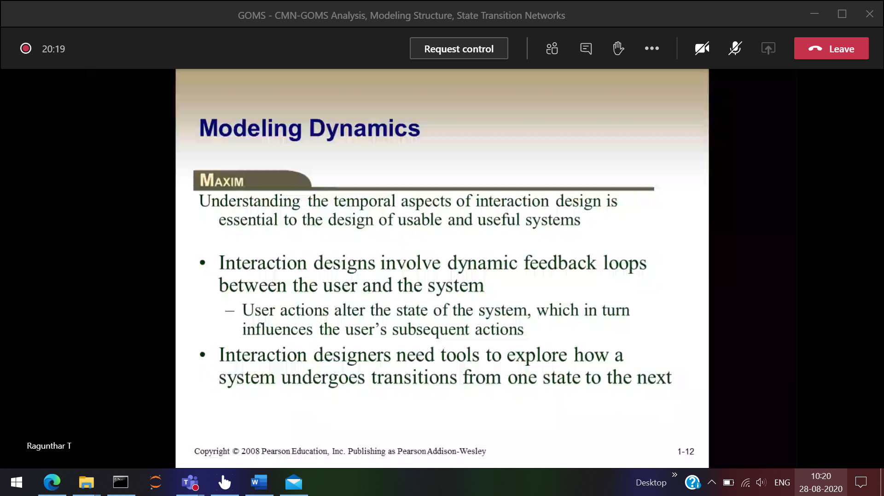

1 operation done 🡪 then the response should be done, after that we can able to proceed further

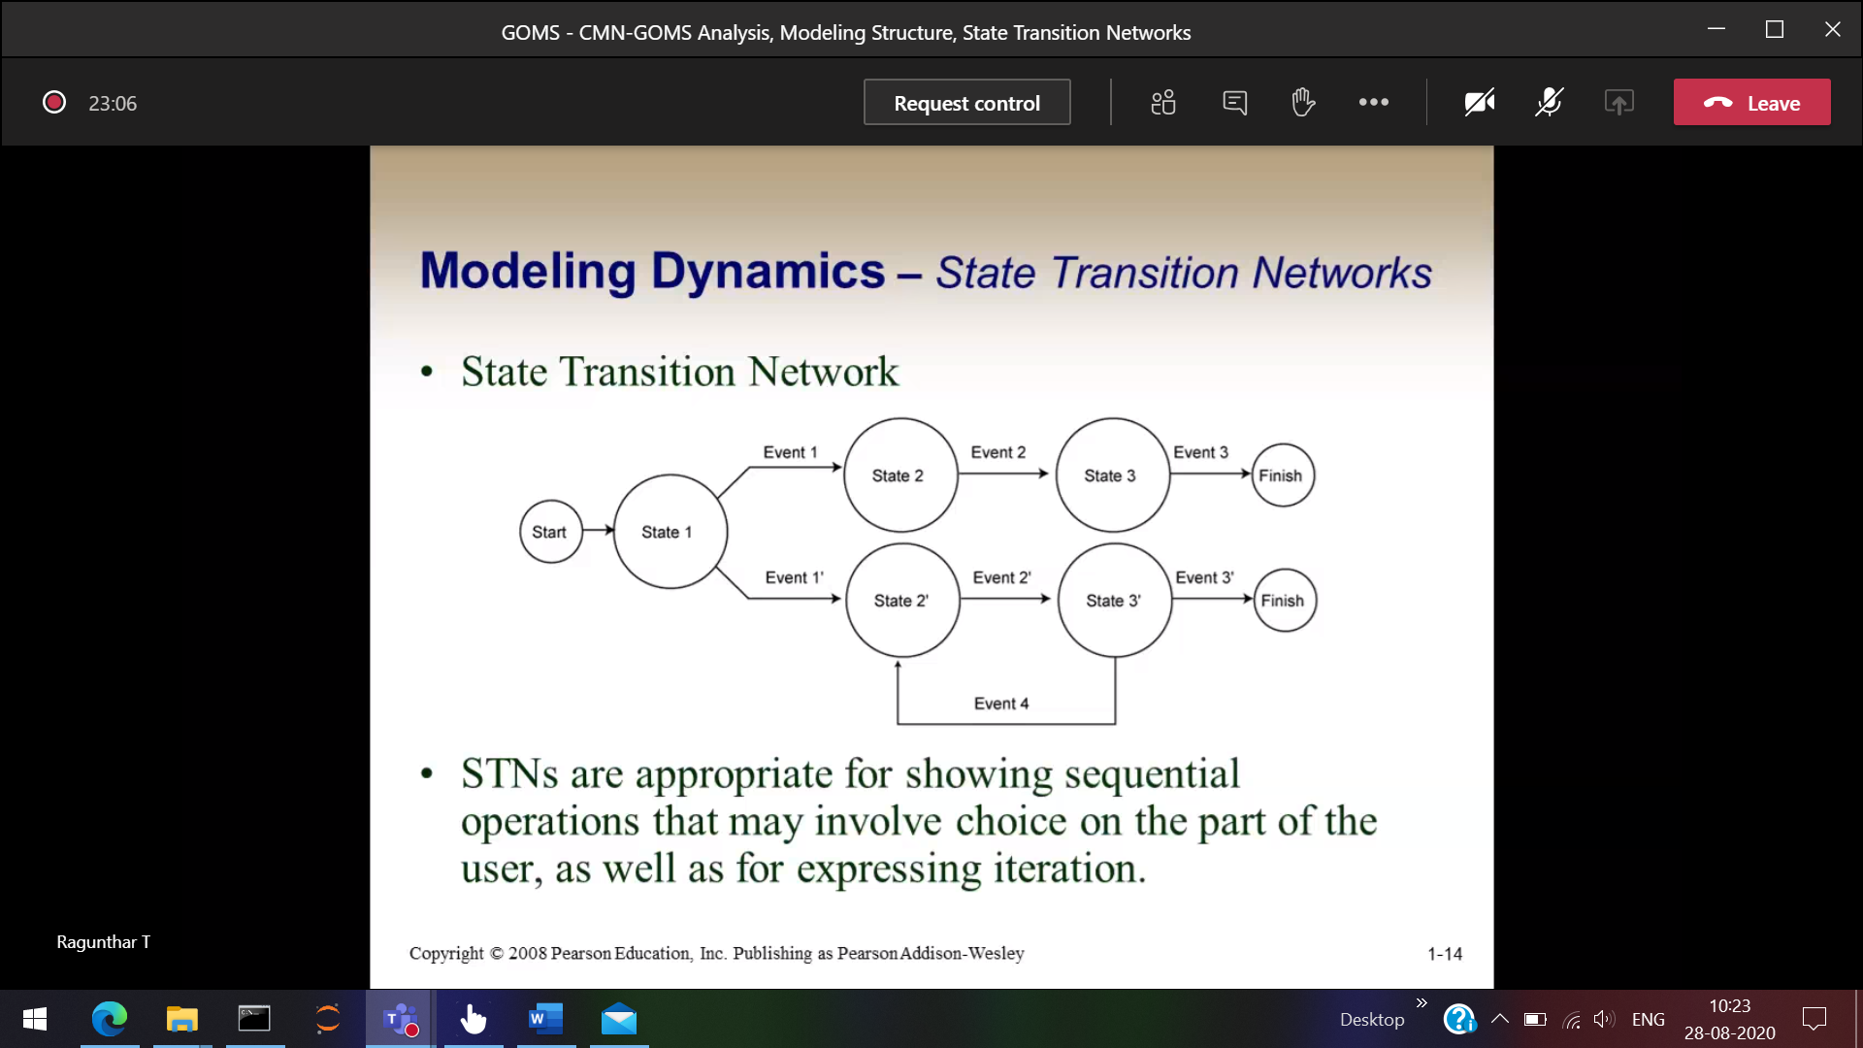In paint we want to 2 jobs

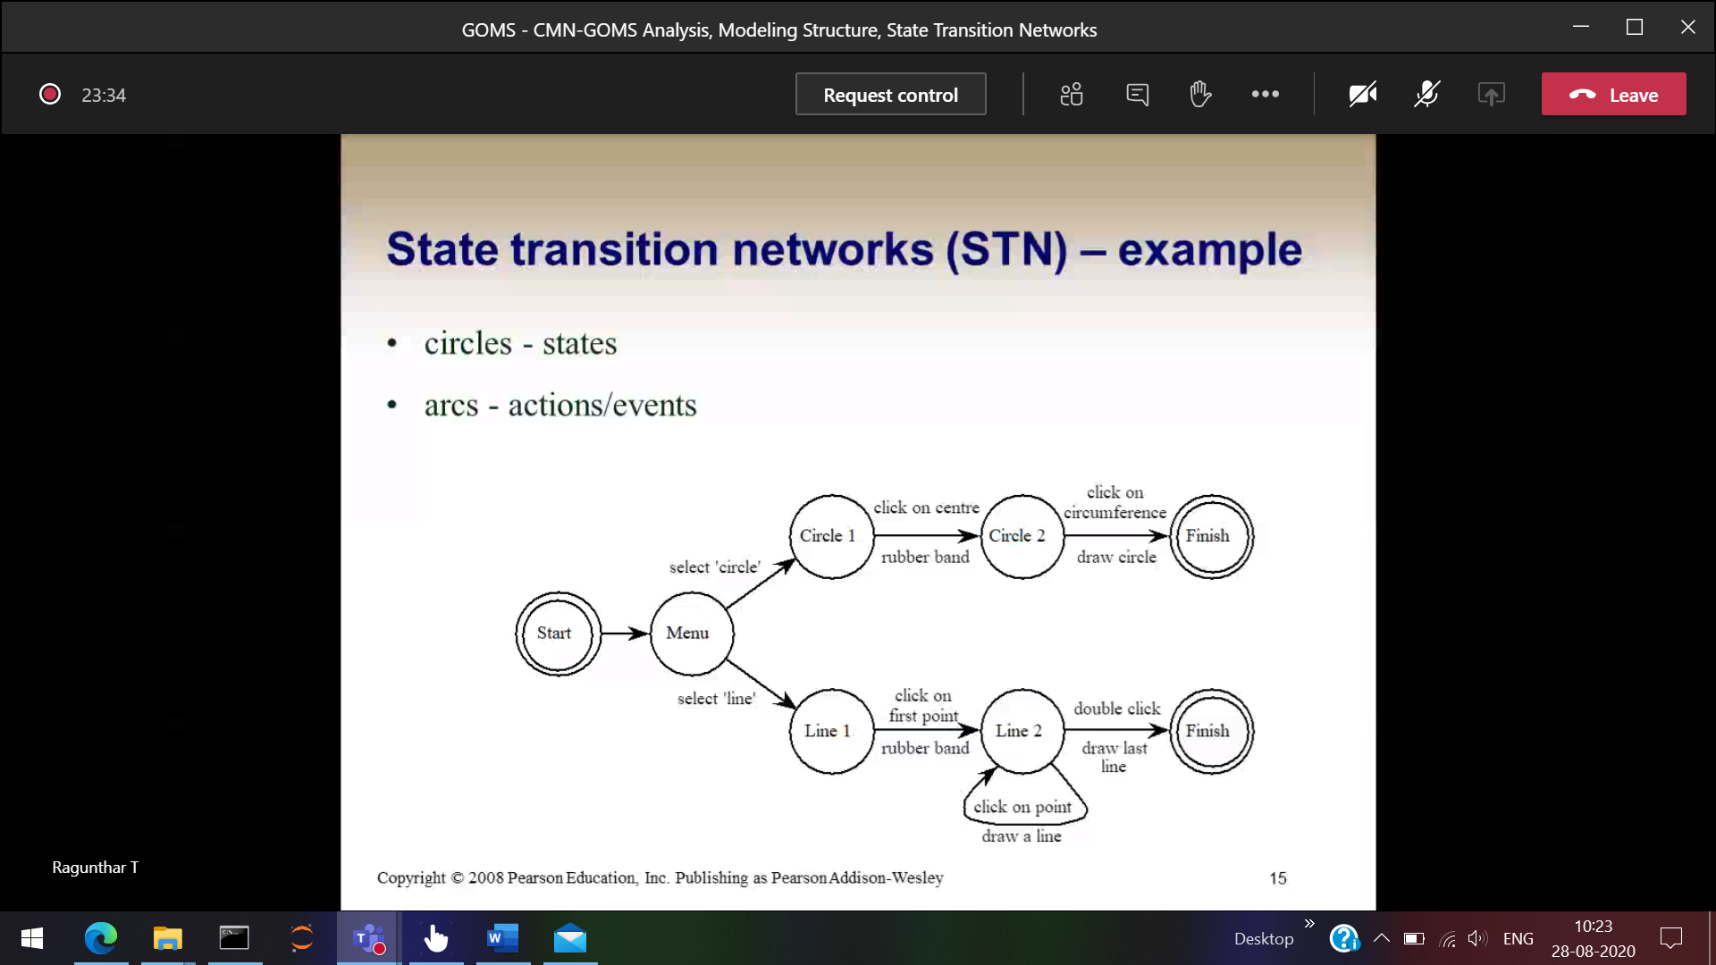

Arrow 🡪 actions

Circle 🡪 Status after that particular action

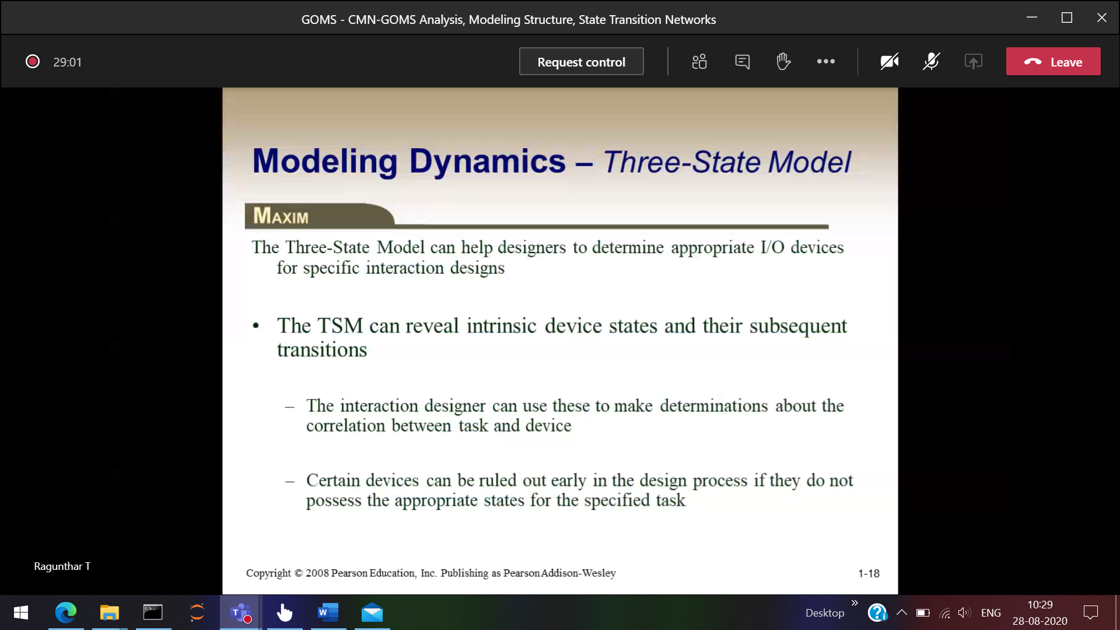

To draw circle 🡪 Mouse   
To do programming 🡪 Keyboard

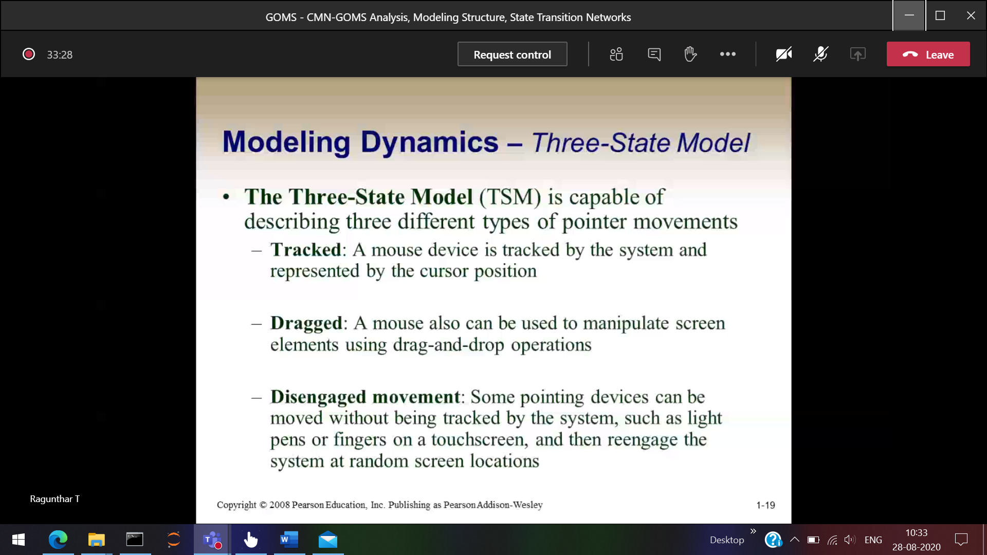

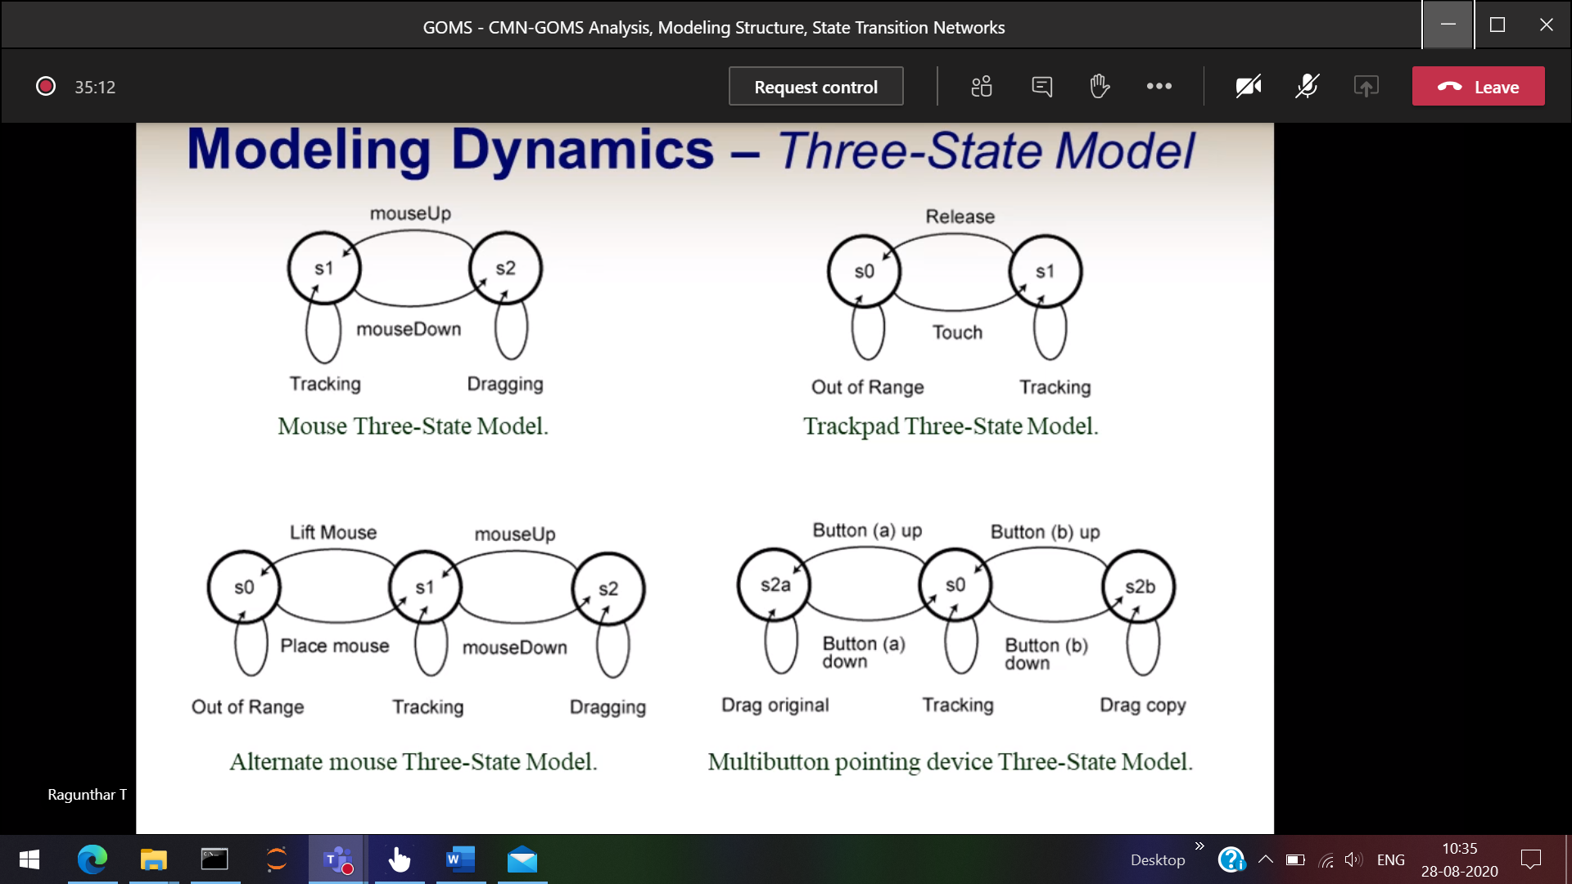

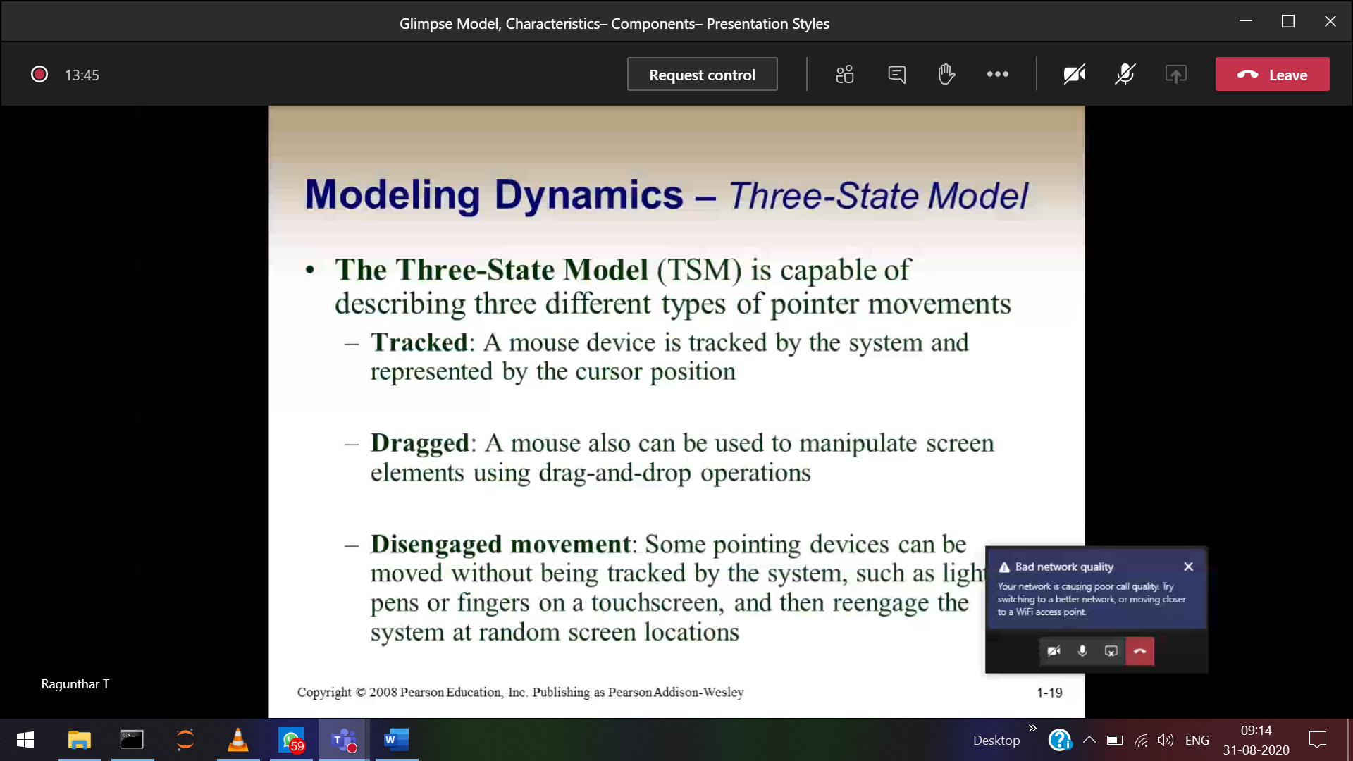

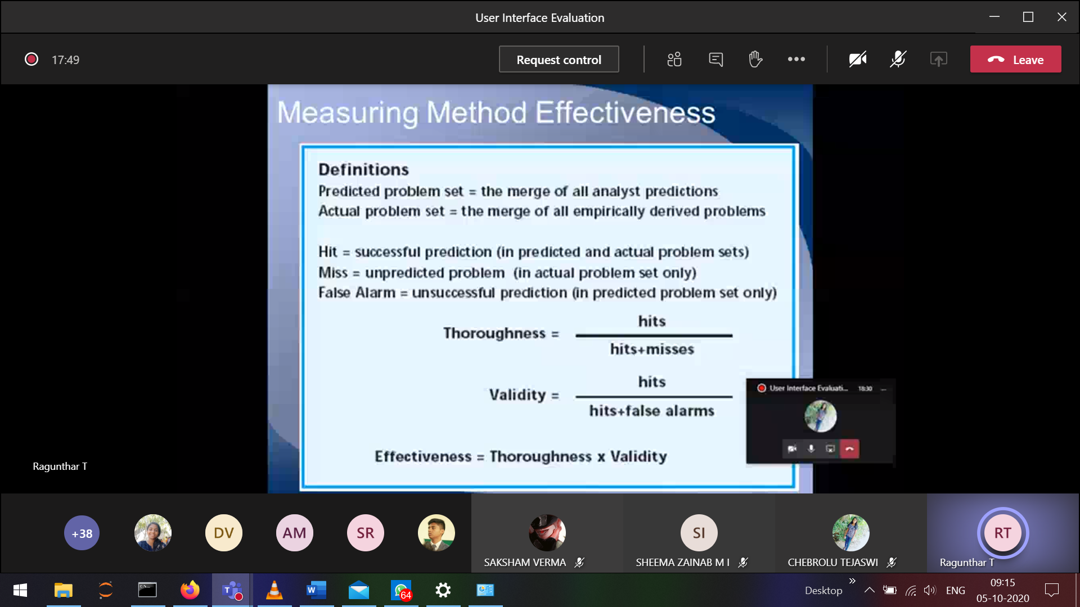

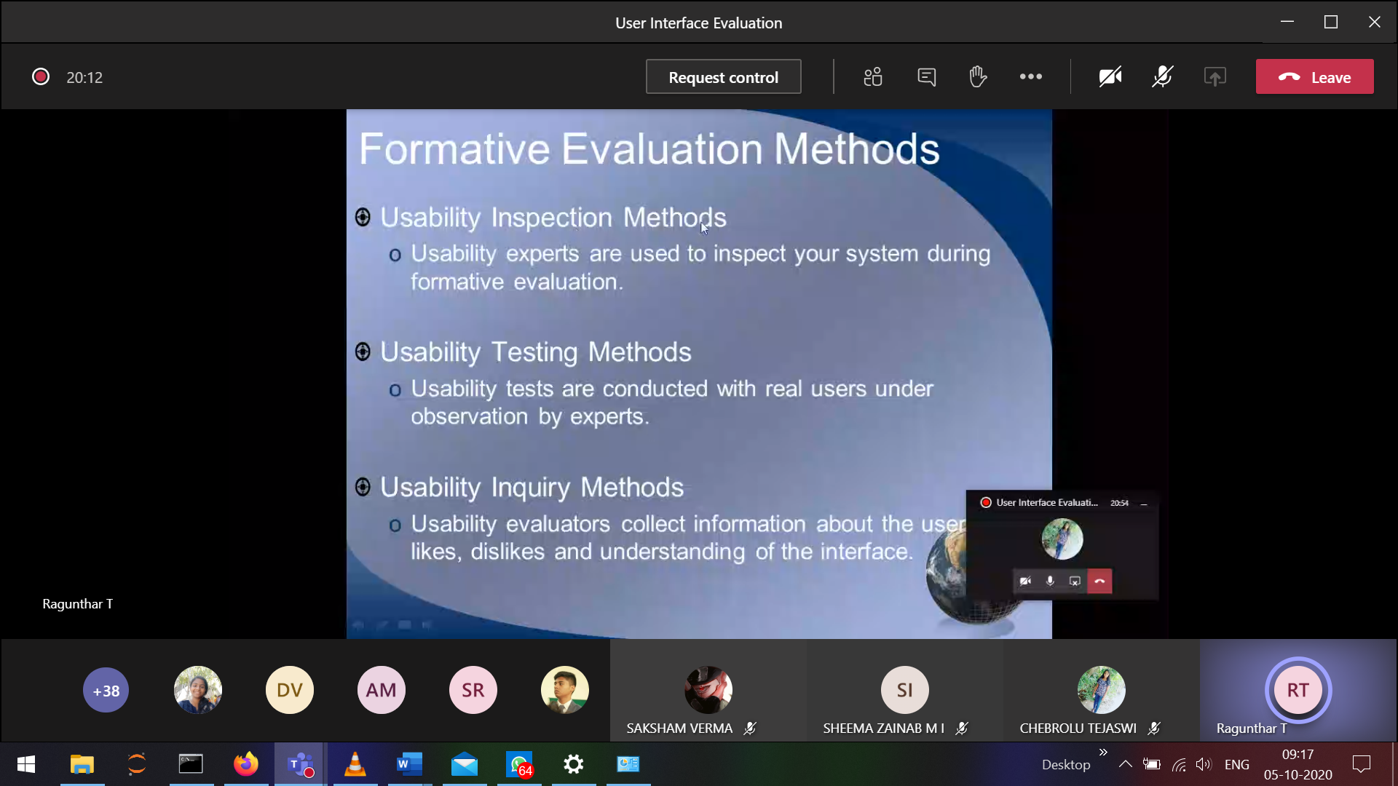

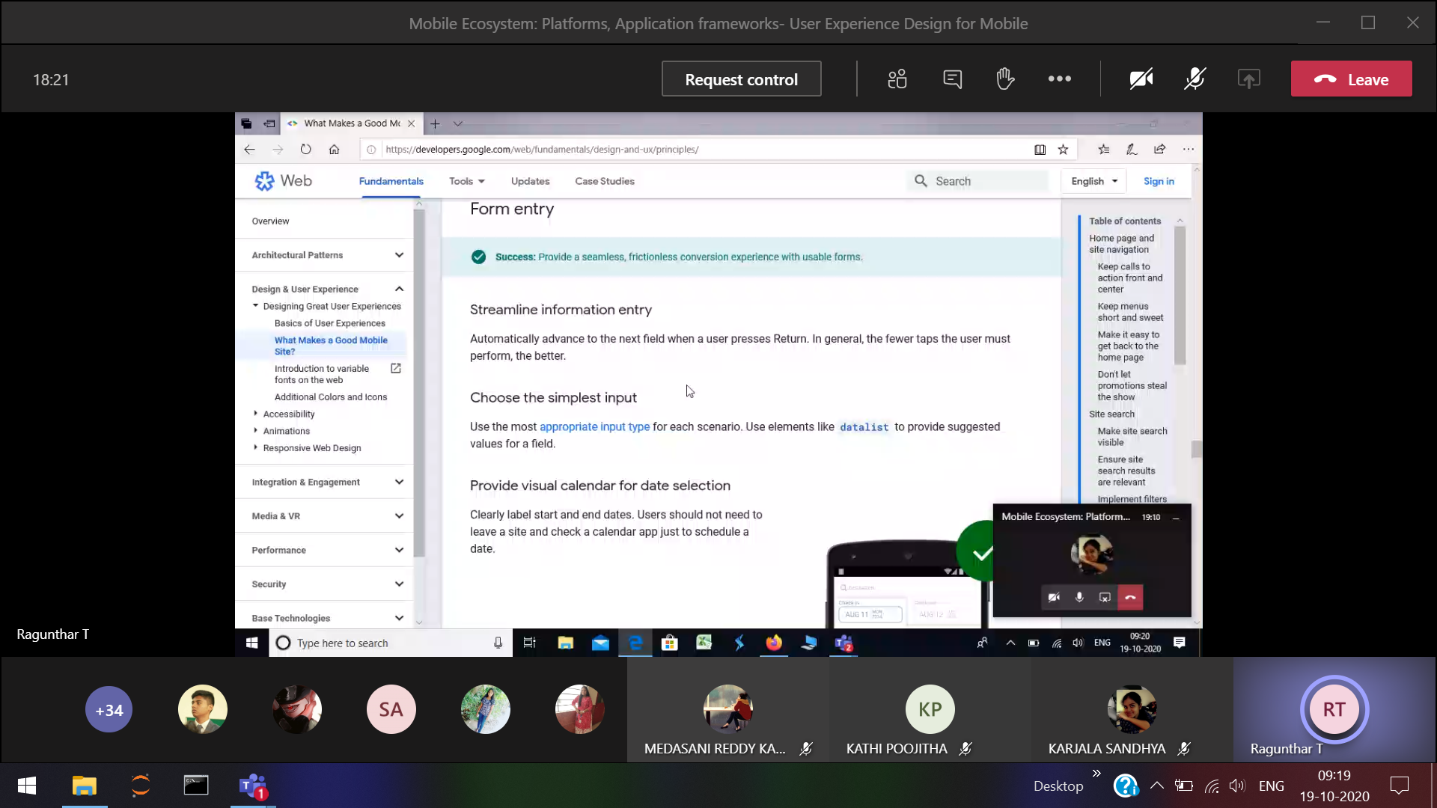

Evaluation process

